**ASSIGNMENT QUESTIONS**

**$**

**LECTURES PLAN**

**ADV. MANUFACTURING CAD/CAM**

**IDEAL SCHOOL OF ENGINEERING**

JHINKHARADA, BHUBANESWAR – 752052

**DEPARTMENT OF MECHANICAL ENGINEERING**

**MODULE – I**

**ASSIGNMENT QUESTIONS**

**Ch. -1**

|  |  |  |  |  |
| --- | --- | --- | --- | --- |
| **Sl. No.** | **Group** | **Ch. No.** | **Ques. No.** | **Question** |
| 1 | A | 1 | 1 | What is LBM ? |
| 2 | 2 | What is LASER ? |
| 3 | 3 | Define EDM. |
| 4 | 4 | Define PAM. |
| 5 | 5 | State to application of LBM. |
| 6 | 6 | What is Plasma and what are the gases used for PAM ? [2016(s]) |
| 7 | 7 | What is the circuit voltage and spark gap in EDM? [2016(s)] |
| 8 | 8 | Differentiate between conventional and Nontraditional machining process.[2016(s),2019(S)] |
| 9 | 9 | What are the material used for tool on ECM ? [2017w,2019(S)] |
| 10 | 10 | Write down the application of PAM. [2017s] |
| 11 | 11 | What is the use of EBM ? [2017s] |
| 12 | 12 | What is ECM ? [2017s] |
| 13 | 13 | Write down the application of AJM. ? [2017s] |
| 14 | 14 | List common abrasive powder used in AJM?[2019(s)] |
| 15 | 15 | State the principle of ECM [2018] |
| 1 | B | 1 | 1 | What is EDM ? Write down its application. |
| 2 | 2 | With neat sketch explain in brief, the working principle of ECM. |
| 3 | 3 | Classify NTM and discuss basic need of NTM. [2016(s) |
| 4 | 4 | State advantages and disadvantage of EDM. |
| 5 | 5 | Write short notes on a) PAM c) LBM |
| 6 | 6 | What is non-conventional machining process ? Explain any one of them. |
| 7 | 7 | Explain AJM ? Explain in details its application.[2016(s) |
| 8 | 8 | With neat sketch explain the EDM process with its application.[2016(s) |
| 9 | 9 | Describe working principle of ECM and its function with neat sketch. |
| 10 | 10 | Write down the relative advantage and disadvantages of PAM ?[2016(s) |
| 11 | 11 | Explain the working principle of PAM with neat sketch. [2016(s) |
| 12 | 12 | Write down the advantage And dis advantage of EDM. [2017(w),2019(S)] |
| 13 | 13 | What is NTM and classify. [2017w] |
| 14 | 14 | Write down the advantage and disadvantage of LBM. [2017(w)] |
| 15 | 15 | Write down the working principle of AJM [2017s] |
| 16 | 16 | State advantages, disadvantages andvarious application of ECM. [2018,2019(s)] |
| 17 | 17 | Differentiate between conventional and non-conventional machining process. [2018] |
| 18 |  |  | 18 | What is LASER? Differentiate LBM and EBM. [2019(S)] |
| 1 | C | 1 | 1 | Explain AJM ? Explain in details its application.[2016(s) |
| 2 | 2 | With neat sketch explain the EDM process with its application.[2016(s),2019(S)] |
| 3 | 3 | Describe working principle of ECM and its function with neat sketch. |
| 4 | 4 | Write down the relative advantage and disadvantages of PAM ?[2016(s) |
| 5 | 5 | Explain the working principle of PAM with neat sketch. [2016(s), 2019(S)] |
| 6 | 6 | Write down the advantage And dis advantage of EDM. [2017(w)] |
| 7 | 7 | What is NTM and classify. [2017w] |
| 8 | 8 | Write down the advantage And dis advantage of LBM. [2017(w)] |
| 9 | 9 | Write down the working principle of AJM [2017s] |
| 10 | 10 | Write down advantage, disadvantage and application of EBM [2018] |
| 11 | 11 | Explain the working principle, advantage, disadvantage and application of USM. |
| 12 | 12 | Explain how Electron-beam machining is carried out.[2019(s)] |

**MODULE – II**

**Ch. – 3**

|  |  |  |  |  |
| --- | --- | --- | --- | --- |
| **Sl. No.** | **Group** | **Ch. No.** | **Ques. No.** | **Question** |
| 1 | A | 3 | 1 | What is NC System ? [2016(s), 2015-s, 2017w, 2019(S)] |
| 2 | 2 | Write the components of DNC. [2010-s] |
| 3 | 3 | Define NC machining. [2011s, 2012 (s),2012-w), 2014(w)] |
| 4 | 4 | State the types of NC system. [2009(s)] |
| 5 | 5 | What is DNC and CNC [2014(s & w), 2013(s), 2010s, 2009(s), 2018] |
| 6 | 6 | What is meant by machining centre? [2009(s)] |
| 7 | 7 | Define part programme. [2012(s)] |
| 8 | 8 | Define machine zero. [2013(w)] |
| 9 | 9 | What is adaptive control system ? [2015, 2013(s)] |
| 10 | 10 | Define work zero. [2016(s), 2018] |
| 11 | 11 | What is “Interpolation” and list the types of interpolation. 2016(s) |
| 12 | 12 | What is preparatory function and write 2 G-code with its function.2016(s) |
| 13 | 13 | List two advantages of using NC machines. |
| 1 | B | 3 | 1 | What are the advantages and disadvantages of NC machine tool over conventional machines. [2010s, 2012(s), 2012(w), 2013(w) |
| 2 | 2 | Differentiate between machine centre and machining centre. [2013(w)] |
| 3 | 3 | Describe the economics of NC system. [2012(s),2015-s] |
| 4 | 4 | What is part programming & classify. [2016s] |
| 5 | 5 | Explain “Adaptive control” system. [2012(s), 2017s] |
| 6 | 6 | CNC machines are preferred over NC machines justify.[2009(s)] |
| 7 | 7 | What is adaptive control? Briefly explain.[2009(s), 2013(s), 2014(s)] |
| 8 | 8 | Differentiate between CNC & NC. [2010(s)] |
| 9 | 9 | Describe tool positioning system used in NC programming. [2016(s), 2017s,2019(s)] |
| 10 | 10 | Explain the following with respect to NC system.  a) Machine zero  b) Work zero |
| 11 | 11 | Tool zero & Tool Offset [2014(s), 2015-s] |
| 12 | 12 | What are the important components of a NC system? Describe in brief. 2019(S)] |
| 1 | C | 3 | 1 | What are the applications of NC? [2018] |
| 2 | 2 | Explain “Contouring” system. [Page-879, Raghuwansi] |
| 3 | 3 | Explain G-code and M-code NC part programming. [2010(s), 2012(w), 2013(s), 2015-s, 2017s, 2018] |
| 4 | 4 | Describe any two of the following types of NC system with neat sketch.  a) Point-to-point  b) Straight cut  c) Contouring. [2009(s), 2010(s),2012(w), 2015-s, 2017w] |
| 5 | 5 | Explain the NC system with block diagram. [2014(s), 2018] |
| 6 | 6 | What is CNC & DNC ? Explain with respect to Block Digram. [2009(s), 2010s,2012(w), 2017s] |
| 7 | 7 | Describe coordinate systems of NC machine tools. 2009s, 2012(s), 2013s, 2014-w, 2015-s] |
| 8 | 8 | Describe complete part program of following figure using G-code & M-code ( 2012(s),2015-s]  C:\Users\GOPAL\Desktop\GOP.jpg |
| 9 | 9 | Describe the components of NC system. [2013(s), 2014(s), 2015-s] |
| 10 | 10 | untitledWrite down the simple part programme to make this job from the given billet size on a CNC lathe machine; without any repetition a cycle. [2014(s)]  BILLET SIZE - Φ70 X 120 |
| 11 | 11 | Prepare a part programme for lathe operation which consists of facing, cleaning cut, reduction of dia to 16mm from 25mm dia., feed 200mm/min, speed=800rpm, depth of cut 2mm/cut  16  40  25  60  (0, 0) |
| 12 | 12 | 1Write down a part program for the diagram. [2013(w)]    BILLET SIZE - Φ55 X 105 |
| 13 | 13 | Describe various types of NC co-ordinate. [2017s] |
| 14 |  |  | 14 | Differentiate between NC,CNC & DNC. [2019(S)] |

**MODULE – III**

**Ch. – 2 & 4**

|  |  |  |  |  |
| --- | --- | --- | --- | --- |
| **Sl. No.** | **Group** | **Ch. No.** | **Ques. No.** | **Question** |
| 1 | **A** | 2 | 1 | Define automation. [2014(s & w), 2013(s), 2011(w), 2017w, 2017s,2019(s)] |
| 2 | 2 | List types of automation. [ 2011w, 2012(s)] |
| 3 | 3 | List two applications of automation.[2013(w)] |
| 4 | 4 | List advantages and disadvantages of automation.[2019(s)] |
| 5 | 5 | Write the need of automation.[2017s, 2018] |
| 6 | 4 | 1 | Why gripper in industrial robot is provided? |
| 7 | 2 | Write the applications of Robot. [2011S,2012(s)] |
| 8 | 3 | Define robot. [2013(s), 2014s, 2017s,2019(s)] |
| 9 | 4 | What do you mean by robot anatomy? [2009(S),2012(w), 2015-s] |
| 10 | 5 | What is function of sensor in robot? [2015-s] |
| 11 | 6 | In which way the joints and links on an industrial robot are used? |
| 12 | 7 | List two applications of robot. [Page-909(Raghuwansi)] |
| 13 | 8 | Define robot and objective of using industrial robot. 2016(s)  What is AGVS ? [2017w] |
| 14 | 9 | What do you mean by robotics. [2018] |
| 1 | B | 2 | 1 | Define Automation .State its need and classify it. [2014 (w), 2013(s), 2012(s), 2011(s), 2010(s)] |
| 2 | 2 | Explain the advantages of automation. [2018] |
| 3 | 3 | List types of automation. [2015-S, 2017w, 2018,2019(s)] |
| 4 | 4 | Explain briefly about types of automation. [2013(s)] |
| 5 | 5 | Explain the need of automation. [2015(s), 2014(s), 2013(N), 2012(s), 2012(w)] |
| 6 | 6 | Which type of automation is most adopted, explain. [2017(s)] |
| 7 | 4 | 1 | Explain briefly different types of end effect or used in industrial robot.[2009s, [2012(s), 2014s] |
| 8 | 2 | What is accuracy and repeatability of the robot? [2010s,2012(s), 2014-w, 2015-s] |
| 9 | 3 | Classify the Robot. [2013w] |
| 10 | 4 | Mention briefly different elements of robot. [2009(S), 2015-s] |
| 11 | 5 | What do you mean by robot configuration ? State and explain the same in brief. 2010s, 2013(s) |
| 12 | 6 | Give various types of end effectors with diagram. [2009(s), 2010s, 2011(s), 2014(s), 2015-s, 2017w, 2018] |
| 13 |  |  | 7 | Explain industrial application of robot.[2019(s)] |
| 1 | C | 2 | 1 | 4. Explain briefly about types of automation. [2013(s)] |
| 2 | 2 | Explain the need of automation. [2015(s),2014(s),2013(N),2012(s),2012(w)] |
| 3 | 3 | Which type of automation is most adopted, explain. [2017(s)] |
| 4 | 4 | 1 | What are the similarities and dissimilarities between robot & NC machines? Pg.-909, Raghuwansi)] |
| 5 | 2 | Explain the polar coordinate systems of robot with neat sketch.[Page-909(Raghuwansi)] |
| 6 | 3 | Explain any two sensors used in robot technology. [2009(s), 2018] |
| 7 | 4 | Write down various robot configuration.  [2009(s), 2011(s), 2012(s),2012(w),2013(s), 2014(s), 2015-s,2019(s)] |
| 8 | 5 | Describe robot configurationand explain the accuracy and repeatability of the robot.[2018] |
| 9 | 6 | What do you mean by Robot Anatomy ? Explain in details. [2014-w] |
| 10 | 7 | Describe the main component of robot [2016(s)] |
| 11 | 8 | Discuss various deign of robot arm. [2017w] |
| 12 | 9 | Explain various types of sensor used in Robot. [2017s] |

**MODULE – IV**

**Ch. –5**

|  |  |  |  |  |
| --- | --- | --- | --- | --- |
| **Sl. No.** | **Group** | **Ch. No.** | **Ques. No.** | **Question** |
| 1 | A | 5 | 1 | Define FMS. .[2013(s), 2014(s), 2015-s,2019(s)] |
| 2 | 2 | List some types of workstation typically found in FMS. [Page-448, (P. Groover)] |
| 3 | 3 | Write two applications of FMS [2010s] |
| 4 | 4 | Write down the components of FMS. [2009(S),2012(w)] |
| 5 | B | 5 | 1 | Identify the needs of FMS. [2012(s), 2017s] |
| 6 | 2 | Explain about workstation of FMS. [Page-448, P. Groover)] |
| 7 | 3 | List advantages and disadvantages of FMS.[2019(s)] |
| 8 | C | 5 | 1 | Define FMS ? What are the component of FMS and explain them.  [2010s,2012(s), 2012(w), 2014(s), 2015-s, 2018,2019(s)] |
| 9 | 2 | State the advantages of FMS. Explain the components in brief. [2013(w), 2017w] |
| 10 | 3 | What are the various flexible manufacturing equipments ? [2017w] |

**MODULE – V**

**Ch. - 6**

|  |  |  |  |  |
| --- | --- | --- | --- | --- |
| **Sl. No.** | **Group** | **Ch. No.** | **Ques. No.** | **Question** |
| 1 | A | 6 | 1 | Define CAD, CAM and CIM[2010s,2012(w), 2013(s), 2014s, 2017w] |
| 2 | 2 | Define CAM. [2010s,2012(s), 2013(s), 2014s, 2017w] |
| 3 | 3 | State reason for implementing CAD. [2011s] |
| 4 | 4 | State benefits of CAD. [2012(s), 2017w] |
| 5 | 5 | Define CIM. [2009(s), 2010s, 2011s,2012(s),2012(w), 2015-s, 2018] |
| 6 | 6 | List some main activities under CIM. [Page-458, (P. Groover)] S |
| 7 | 7 | Out line the relation among CAD, CAM, [Page-690(Hajra Choudhury)] S |
| 8 | 8 | Write the application of CAD. [Page-690 Hajra Choudhury] |
| 1 | B | 6 | 1 | Write down the application of CAD and CAM. [2009(S) |
| 2 | 2 | State the benefits of CAD & CAM software. [2014s, 2015-s, 2018] |
| 3 | 3 | Discuss the different elements of CIM. [2013(s) |
| 4 | 4 | Explain CAD & CIM hardware [2013(s) |
| 1 | C | 6 | 1 | Short notes on :-  a) CIM  b) CAD software [2014(N)] |
| 2 | 2 | Write the concept and background of CIM, also explain the CIM hardware and software. [2015-s, 2017w] |
| 3 | 3 | What are the benefits of CAM. |
| 4 | 4 | Differentiate between CAD and CAM. |

***IDEAL SCHOOL OF ENGINEERING***

*JHINKHARADA, BHUBANESWAR – 752054*

***DEPARTMENT OF MECHANICAL ENGINEERING***

***Non-Traditional Machining***

*• Traditional machining is mostly based on removal of materials using tools that are harder than the materials themselves.*

*properties are sometimes impossible to machine using traditional machining processes.*

*• Traditional machining methods are often ineffective in machining hard materials like ceramics and composites or machining under very tight tolerances as in micromachined components.*

*• The need to avoid surface damage that often accompanies the stresses created by conventional machining.*

***Classification of Non-Traditional Machining***

*Mechanical-Ultrasonic machining.(USM)*

*Abrasive Jet machining(AJM)*

*Thermal- Electro Dishcharge machining(EDM)*

*Electron Beam machining(EBM)*

*Laser Beam machining(LBM)*

*Chemical- Electro chemical machining(ECM)*

***Advantage of NTM***

*1.High accuracy.*

*2.It gives very good surface finish.*

*3.Quick operation.*

*4.Close tolerance can be obtained.*

***Disadvantage of NTM***

*1.High cost.*

*2.complex set up.*

*3.Skilled operator required.*

***Electrochemical machining****(ECM)*

*It is a machining process in which electrochemical process is used to remove materials from the workpiece. In the process, workpiece is taken as anode and tool is taken as cathode. The two electrodes workpiece and tool is immersed in an electrolyte (such as NaCl).It is the reverse of electroplating and follows law of electrolys.*

***Construction.***

*Fig: Schematic illustration of electrochemical machining
 *

*I*

***Working***

*ECM working is opposite to the electrochemical or galvanic coating or deposition process.*

*During electrochemical machining process, the reactions take place at the electrodes i.e. at the anode (workpiece) and cathode (tool) and within the electrolyte.*

### *****Working Process*****

* *First the workpiece is assembled in the fixture and tool is brought close to the workpiece. The tool and workpiece is immersed in a suitable electrolyte.*
* *After that, potential difference is applied across the w/p (anode) and tool (cathode). The removal of material starts. The material is removed as in the same manner as we have discussed above in the working principle.*
* *Tool feed system advances the tool towards the w/p and always keeps a required gap in between them. The material from the w/p is comes out as positive ions and combine with the ions present in the electrolyte and precipitates as sludge. Hydrogen gas is liberated at cathode during the machining process.*
* *Since the dissociation of the material from the w/p takes place at atomic level, so it gives excellent surface finish.*
* *The sludge from the tank is taken out and separated from the electrolyte. The electrolyte after filtration again transported to the tank for the ECM process.*

### *****Advantages*****

* *Negligible tool wear.*
* *Complex and concave curvature parts can be produced easily by the use of convex and concave tools.*
* *No forces and residual stress are produced, because there is no direct contact between tool and workpiece.*
* *Excellent surface finish is produced.*
* *Less heat is generated.*

### *****Disadvantages*****

* *The risk of corrosion for tool, w/p and equipment increases in the case of saline and acidic electrolyte.*
* *Electrochemical machining is capable of machining electrically conductive materials only.*
* *High power consumption.*
* *High initial investment cost.*

***Tools Used for the Lecture:*** *CHALK, DUSTER & BLACK BOARD.*

***Description of Lecture with Figure (If Any):***

***Electrical discharge machining****(****EDM****),*

*also known as spark machining, spark eroding is a manufacturing process whereby a desired shape is obtained by using electrical discharges (sparks).Material is removed from the work piece by a series of rapidly recurring current discharges between two*[*electrodes*](https://en.wikipedia.org/wiki/Electrode)*, separated by a*[*dielectric*](https://en.wikipedia.org/wiki/Dielectric)[*liquid*](https://en.wikipedia.org/wiki/Liquid)*and subject to an electric*[*voltage*](https://en.wikipedia.org/wiki/Voltage)*. One of the electrodes is called the tool-electrode, or simply the "tool" or "electrode," while the other is called the workpiece-electrode, or "work piece." The process depends upon the tool and work piece not making actual contact.*

*When the voltage between the two electrodes is increased, the intensity of the*[*electric field*](https://en.wikipedia.org/wiki/Electric_field)*in the volume between the electrodes becomes greater than the strength of the dielectric , which breaks down, allowing current to flow between the two electrodes. This phenomenon is the same as the*[*breakdown of a capacitor (condenser)*](https://en.wikipedia.org/wiki/Capacitor#Breakdown_voltage)*. As a result, material is removed from the electrodes. Once the current stops (or is stopped, depending on the type of generator), new liquid dielectric is usually conveyed into the inter-electrode volume, enabling the solid particles (debris) to be carried away and the insulating properties of the dielectric to be restored. Adding new liquid dielectric in the inter-electrode volume is commonly referred to as "flushing." Also, after a current flow, the*[*difference of potential*](https://en.wikipedia.org/wiki/Difference_of_potential)*between the electrodes is restored to what it was before the breakdown, so that a new liquid dielectric breakdown can occur.*

***Construction:***

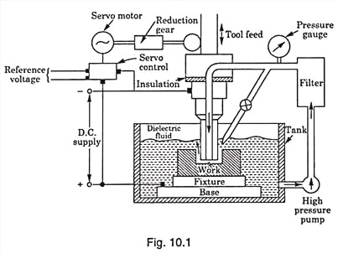

***Working:***

*In Electrical discharge machining; a potential difference is applied across the tool and w/p in pulse form. The tool and workpiece must be electrically conductive and a small gap is maintained in between them. The tool and workpiece is immersed in a dielectric medium (kerosene ). As the potential difference is applied, electrons from the tool start to move towards the workpiece. Here the tool is negative and w/p is positive. The electrons moving from the tool to the w/p collide with the molecules of dielectric medium. Due to the collision of electrons with the molecule, it gets converted into ions. This increases the concentration of electrons and ions in the gap between the tool and w/p. The electron moves towards the w/p and ions towards the tool. An electric current is set up in between the tool and w/p and called as plasma. As the electrons and ions strikes the w/p and tool, its kinetic energy changes to heat energy. The temperature of the heat produced is about 10000 degree Celsius. This heat vaporizes and melts the material from the workpiece. As voltage is break down, the current stops to flow between the tool and w/p. And the molten material in the w/p is flushed by circulating dielectric medium leaving behind a crater.*

*The spark generation is not continuous because constant voltage is not applied across the electrodes. The voltage is applied in pulse form.*

***Advantages of EDM***

* *Complex shapes that would otherwise be difficult to produce with conventional cutting tools.*
* *Extremely hard material to very close tolerances.*
* *Very small work pieces where conventional cutting tools may damage the part from excess cutting tool pressure.*
* *There is no direct contact between tool and work piece. Therefore, delicate sections and weak materials can be machined without perceivable distortion.*
* *A good surface finish can be obtained; a very good surface may be obtained by redundant finishing paths.*
* *Very fine holes can be attained.*
* *Tapered holes may be produced.*

***Disadvantages of EDM***

* *Difficulty finding expert machinists.*
* *The slow rate of material removal.*
* *The additional time and cost used for creating electrodes for ram/sinker EDM.*
* *Reproducing sharp corners on the workpiece is difficult due to electrode wear and*

## *Power consumption is high.*

## *****Application*****

1. It is mostly used by mold making and dies industries.
2. It is used in prototype manufacturing in aerospace, automobile and electronic industries.
3. It is used for coinage die making.
4. It is used to create small holes in variety of application.
5. It is used to disintegrate parts which cannot be disintegrate easily such as broken tools (studs, bolts drill bit and taps) form the workpiece.

When a flowing gas is heated to a sufficiently high temperature to become partially ionized, it is known as ‘plasma’. This is virtually a mixture of free electrons, positively charged ions and neutral atoms.

### ****Plasma arc machining**** is a metal removal process in which the metal is removed by focusing a high-velocity jet of high temperature (11,000°C to 30,000°C) ionized gas on the workpiece. Working Principle of Plasma Arc Machining

***The principle of******plasma arc machining****:*

In a plasma torch, known as the gun or plasmatron, a volume of gas such as H2, N2, 02, etc. is passed through a small chamber in which a high-frequency spark (arc) is maintained between the tungsten electrode (cathode) and the copper nozzle (anode), both of which are water-cooled.

* In certain torches, an inert gas-flow surrounding the main flame is provided to shield the gas from the atmosphere.
* The high-velocity electrons generated by arc collide with the gas molecules and produce dissociation of diatomic molecules of the gas resulting in ionization of the atoms and causing large amounts of thermal energy to be liberated.

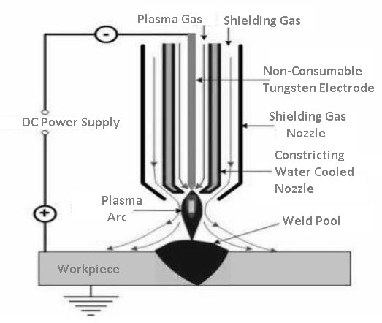

* The plasma forming gas is forced through a nozzle duct of the torch in such a manner as to stabilise the arc.
* The heating of the gas takes place in the compressed zone of the nozzle duct resulting in almost high exit gas velocity and high core temperature up to 16,000 °C.
* The relative plasma jet melts the workpiece material and the high-velocity gas stream effectively blows the molten metal away.
* The depth of heat affected zone depends on the work material, its thickness and cutting speed. On a workpiece of 25 mm thickness, the heat-affected zone is about 4 mm and it is less at high cutting speeds.
* A typical flow rate of the gas is 2 to 11 m/hr. Direct current, rated at about 400 V and 200 kW output is normally required.
* Arc current ranges between 150 and 1000 A for a cutting rate of 250 to 1700 mm/min.

### ****Advantages****

Following are the advantages of PAM that you must know:

* In Plasma Arc Machining, hard as well as brittle metals can be easily machined.
* It can be applied to almost all types of metals.
* The best part of this process is that we get high cutting rate.
* We get a better dimensional accuracy in case of machining small cavities.
* It is a simple process to carry out and a very efficient process.
* It takes a big part in automatic repair of jet engine blades.

### ****Disadvantages****

Apart from the advantages of the Plasma Arc machining let us discuss some of the disadvantages of it:

* PAM involves various equipment but the cost of this equipment is very high.
* This entire machining process consumes a high amount of inert gases.
* Production of narrower surfaces takes place which is unnecessary.
* The most harmful part of PAM is that metallurgical changes takes place on the surface.
* The operator or person handling the whole process must take proper precautions. This process can affect human eyes so a proper googles or helmet must be worn by an operator.

### ****Applications****

* It is mostly used for cryogenic, high temperature corrosion resistant alloys.
* It is also used in case of titanium plate up to 8mm thickness.
* PAM is used in nuclear submarine pipe system and for welding steel rocket motor case.

PAM is prominent for the applications related to stainless tube and tube mills.

***Laser Beam Machining (LBM):***

***It****is a form of machining process in which laser beam is used for the machining of metallic and non-metallic materials. In this process, a laser beam of high energy is made to strike on the workpiece, the thermal energy of the laser gets transferred to the surface of the w/p (workpiece). The heat so produced at the surface heats, melts and vaporizes the materials from the w/p.****Light amplification by stimulated emission of radiation is called LASER****.*

***Construction:***

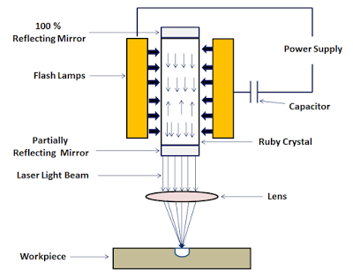

## ****How Laser is Produced :****

* A high voltage power supply is applied across the flash tube. A capacitor is used to operate the flash tube at pulse mode.
* As the flash is produced by the flash tube, it emits light photons that contain energy.
* This light photons emitted by the flash tube is absorbed by the ruby crystal. The photons absorbed by the atoms of the ruby crystals excite the electrons to the high energy level and population inversion (situation when the number of exited electrons is greater than the ground state electrons) is attained.
* After short duration, this excited electrons jumps back to its ground state and emits a light photon. This emission of photon is called spontaneous emission,
* The emitted photon stimulates the excited electrons and they starts to return to the ground state by emitting two photons. In this way two light photons are produced by utilizing a single photon. Here the amplification (increase) of light takes place by stimulated emission of radiation.
* Concentration of the light photon increases and it forms a laser beam.
* 100 % reflecting mirror bounces back the photons into the crystal. Partially reflecting mirror reflects some of the photons back to the crystal and some of it escapes out and forms a highly concentrated laser beam. A lens is used to focus the laser beam to a desired location*.*

**Tools Used for the Lecture:** CHALK, DUSTER & BLACK BOARD.

**Description of Lecture with Figure (If Any):**

## ****Working of Laser Beam Machining:****

A very high energy laser beam is produced by the laser machines. This laser beam produced is focused on the workpiece to be machined.

When the laser beam strikes the surface of the w/p, the thermal energy of the laser beam is transferred to the surface of the w/p. this heats, melts,  vaporizes and finally removes the material form the workpiece . In this way laser beam machining works.

## ****Advantages****

* It can be focused to a very small diameter.
* It produces a very high amount of energy, about 100 MW per square mm of area.
* It is capable of producing very accurately placed holes.
* Laser beam machining has the ability to cut or engrave almost all types of materials, when traditional machining process fails to cut or engrave any material.
* Since there is no physical contact between the tool and workpiece. The wear and tear in this machining process is very low and hence it requires low maintenance cost
* This machining process produces object of very high precision. And most of the object does not require additional finishing
* It can be paired with gases that help to make cutting process more efficient. It helps to minimize the oxidation of w/p surface and keep it free from melted of vaporized materials. Produces a very high energy of about 100 MW per square mm of area.
* It has the ability to engrave or cut almost all types of materials. But it is best suited for the brittle materials with low conductivity.

## ****Disadvantages****

* High initial cost. This is because it requires many accessories which are important for the machining process by laser.
* Highly trained worker is required to operate laser beam machining machine.
* Low production rate since it is not designed for the mass production.
* It requires a lot of energy for machining process.
* It is not easy to produce deep cuts with the w/p that has high melting points and usually cause a taper.
* High maintenance cost.

## ****Application****

1. The laser beam machining is mostly used in automobile, aerospace, shipbuilding, electronics, steeland medical industries for machining complex parts with precision.
2. In heavy manufacturing industries, it is used or drilling and cladding, seam and spot welding among others.
3. In light manufacturing industries, it is used for engraving and drilling other metals.
4. In the electronic industry, it is used for skiving (to join two ends) of circuits and wire stripping.
5. In medical industry, it is used for hair removal and cosmetic surgery.

***Abrasive Jet machining: Abrasive jet machining****(****AJM****), also known as****abrasive micro-blasting****,****pencil blasting****and****micro-abrasive blasting****, is an*[*abrasive blasting*](https://en.wikipedia.org/wiki/Abrasive_blasting)[*machining*](https://en.wikipedia.org/wiki/Machining)*process that uses*[*abrasives*](https://en.wikipedia.org/wiki/Abrasive)*propelled by a high velocity gas to erode material from the workpiece. Common uses include cutting heat-sensitive, brittle, thin, or hard materials. Specifically it is used to cut intricate shapes or form specific edge shapes. Material is removed by fine abrasive particles, usually about 0.001 in (0.025 mm) in diameter, driven by a high velocity fluid stream.*

**

## *Working Principle of Abrasive Jet Machining*

The fundamental principle of Abrasive jet machining involves the use of a high-speed stream of abrasive particles carried by a high-pressure gas or air on the work surface through a nozzle.

The metal is removed due to erosion caused by the abrasive particles impacting the work surface at high speed.With repeated impacts, small bits of material get loosened and a fresh surface is exposed to the jet.

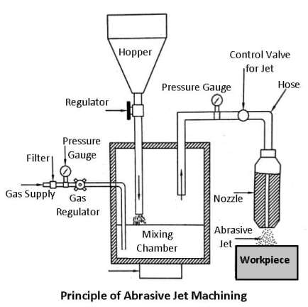

This process is mainly employed for such machining works which are otherwise difficult, such as thin sections of hard metals and alloys, cutting of material which is sensitive of heat damage, producing intricate holes, deburring, etching, polishing etc.

## Applications:

|  |
| --- |
| 1. The process finds application in cutting slots, thin sections, contouring, drilling, for producing shallow crevices, deburring, and for producing intricate shapes in hard and brittle materials. |
| 2. It is often used for cleaning and polishing of plastic, nylon and Teflon components, the frosting of the interior surface of the glass tubes, etching of markings on glass cylinders, etc. |
| 3. It is used for deburring, etching, and cleaning of brittle metals, alloys, and non-metallic materials. |
| 4. Polishing of plastic, Nylon can be done easily. |
| 5. Drilling can be done easily. |
| 6. The fragile material can be easily machined. |

## Advantages of Abrasive Jet Machining:

1. Ability to cut intricate hole shapes in materials of any hardness and brittleness.
2. Ability to cut fragile and heat-sensitive materials without damage as no heat is generated due to the passing of gas or air.
3. Normally inaccessible portions can be machined with fairly good accuracy.
4. Low capital cost.

**Disadvantage of Abrasive Jet Machining:**

1. The material removal rate is slow and its application is therefore limited.
2. Flaring can become large.
3. The machining accuracy is poor and the nozzle wear rate is high.
4. Additional cleaning of the work surface may occur as there is a possibility of sticking abrasive grains in softer materials.
5. It is an expensive process.

***Electron Beam Machining(EBM):***

It is the metal removal process by a high velocity focused beam of electr0ns which heats,melts and vaporizes the work material.

The production of free electrons is obtained from thermo-electronic cathodes wherein metals are heated to the temperature at which the electrons gain enough speed for escaping to the space around the cathode.

The acceleration of the electrons is carried by an electric field while the focussing and concentration are done by controlled magnetic fields.

The kinetic energy of a beam of free electrons is transformed into heat energy as a result of the interaction of the electrons with the workpiece material. EMB is, therefore, a thermo-electric process.

### *Working Principle of Electron Beam Machining*

The figure shows the principle of operation of electron-beam machining. A beam of electrons is emitted from the electron gun which is a triod consisting of:

1. A cathode is a hot tungsten filament (2500°C) emitting high -ve potential electrons.
2. The grid cup, negatively based on the Filament.
3. An anode which is kept at ground potential, and through which the high-velocity electrons pass.

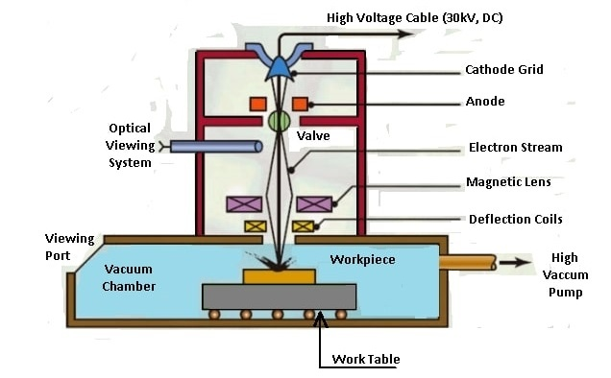

* A gun is provided with an electric current from a high voltage dc source.
* The flow of electrons is regulated by the -ve bias applied to the grid cup.
* Electrons passing through the anode are accelerated to two- thirds of the velocity of light by applying 50 to 150 kV at the anode, and this speed is maintained till they strike the workpiece.
* Due to the pattern of the electrostatic field produced by the grid cup, the electrons are focussed and made to flow in the form of a converging beam through a hole in the anode.
* A magnetic deflection coil is used to make the electron beam circular having a cross-sectional diameter of 0.01 to 0.02 mm and deflect it anywhere.
* As the beam impacts on the workpiece surface. the kinetic energy of high-velocity electrons is immediately converted into the thermal energy and it vaporizes the material at the spot of its impact.
* Power density is very high, it takes a few microseconds to melt and vaporize the material on impact.
* The process is carried out in repeated pulses of short duration.
* The pulse frequency may range from 1 to 16,000 Hz and duration may range from 4 to 64,000 microseconds.

### *Advantages:*

* EBM is an excellent method for micro-finishing. It can drill holes or cut slots which otherwise cannot be made.
* It is possible to cut any known material, metal or nonmetal that can exist in a vacuum.

***Disadvantage:***

* The biggest **disadvantage** is the high equipment cost and employment of high skill operator.
* Besides, only small cuts are possible. Further, the need of vacuum restricts the size of specimens that can be machined.

### *Applications of EBM:*

1. Drill fine gas orifices, less than 0.002 mm, in space nuclear reactors, turbine blades for supersonic aero-engines.
2. To produce wire drawing dies, light-ray orifices and spinnerets to produce synthetic fibres.
3. Produce metering holes in injector nozzles in diesel engines, etc.
4. To scribe thin films.
5. To remove small broken taps from holes.

# *Ultrasonic Machining:*

***Ultrasonic machining****is changing the manufacturing industries with its superlative performance. The main reason why this machining process is used in the manufacturing area is because it evolves less heat in the process. All the operations done with the ultrasonic machining method are cost effective and best in results. Ultrasonic machining is an abrasive process which can create any material into hard and brittle form with the help of its vibrating tool and the indirect passage of abrasive particles towards the work piece. It is a low material removal rate machining process.*

## *****Ultrasonic Machining Process*****

*The tool present in the machine for cutting the materials is made from a soft material as compared to the work piece. The tool is usually made from materials such as soft steels and nickel. When the tool vibrates, the abrasive slurry (liquid) is added which contains abrasive grains and particles. The abrasive slurry is added till the work pieces interacts with the grains. Due to the particles of liquid added, the work brittleness of the work piece abrades the surface meanwhile the tool deforms gradually.*

## *****Working Principle of Ultrasonic Machining*****

*The time spent on****ultrasonic machine****entirely depends on the frequency of the vibrating tool. It also depends on the size of grains of the abrasive slurry, the rigidity and the viscosity as well. The grains used in the abrasive fluid are usually boron carbide or silicon carbide as they are rigid than others. The used abrasive can be carried away easily if the viscosity of the slurry fluid is less.*

## *****Ultrasonic Machining Advantages and Disadvantages*****

*Get to know about the advantages and disadvantages of machining process in order to make the right decision:*

### *****Advantages*****

* *Machined all sorts of hard materials*
* *Produces fine finished and structured results*
* *Produces less heat*
* *Various hole cut shapes due to vibratory motion of the tool*

### *****Disadvantages*****

* *Requires a higher degree of integrity and skills*
* *No certified record of radiography*
* *Unnecessary large grain sizes causes defects.*

***Automation***

* *Automation is the creation of technology and its application in order to control and monitor the production and delivery of various goods and services. It performs tasks that were previously performed by humans. Automation is being used in a number of areas such as manufacturing, transport, utilities, facilities, operations and lately, information technology.*
* *It is classified into 2 types.*
* *Partial automation.*
* *Full automation.*

*Partial automation means the replacement of human activities are partial but full automation means the human participation is totally eliminated.*

***Need of automation:***

### *To increase labor productivity.*

### *To reduce labour cost.*

### *To mitigate the effects of labour shortages*

### *To improve product quality*

### *To reduce manufacturing lead time.*

***Advantages of automation:***

* *Increased throughput or productivity.*
* *Improved quality or increased predictability of quality.*
* *Improved robustness (consistency), of processes or product.*
* *Increased consistency of output.*
* *Reduced direct human labor costs and expenses.*
* *Installation in operations reduces cycle time.*

## *Types of Automation System*

*Automated production systems can be classified into three basic types:*

1. *Fixed automation,*
2. *Programmable automation, and*
3. *Flexible automation.*

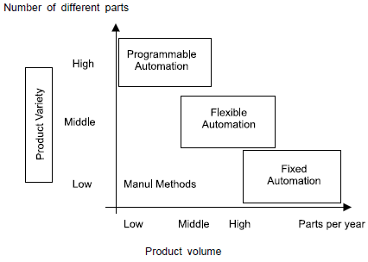

***FIXED AUTOMATION*** *It is a system in which the sequence of processing (or assembly) operations is fixed by the equipment configuration. The operations in the sequence are usually simple. It is the integration and coordination of many such operations into one piece of equipment that makes the system complex.*

*The typical features of fixed automation are:*

1. *High initial investment for custom–Engineered equipment;*
2. *High production rates; and*
3. *Relatively inflexible in accommodating product changes.*

*The economic justification for fixed automation is found in products with very high demand rates and volumes. The high initial cost of the equipment can be spread over a very large number of units, thus making the unit cost attractive compared to alternative methods of production. Examples of fixed automation include mechanized assembly and machining transfer lines.*

***PROGRAMMABLE AUTOMATION*** *In this the production equipment is designed with the capability to change the sequence of operations to accommodate different product configurations. The operation sequence is controlled by a program, which is a set of instructions coded so that the system can read and interpret them. New programs can be prepared and entered into the equipment to produce new products. Some of the features that characterize programmable automation are:*

1. *High investment in general-purpose equipment;*
2. *Low production rates relative to fixed automation;*
3. *Flexibility to deal with changes in product configuration; and*
4. *Most suitable for batch production.*

*Automated production systems that are programmable are used in low and medium volume production. The parts or products are typically made in batches. To produce each new batch of a different product, the system must be reprogrammed with the set of machine instructions that correspond to the new product. The physical setup of the machine must also be changed over: Tools must be loaded, fixtures must be attached to the machine table also be changed machine settings must be entered. This changeover procedure takes time. Consequently, the typical cycle for given product includes a period during which the setup and reprogramming takes place, followed by a period in which the batch is produced. Examples of programmed automation include numerically controlled machine tools and industrial robots.*

***FLEXIBLE AUTOMATION*** *It is an extension of programmable automation. A flexible automated system is one that is capable of producing a variety of products (or parts) with virtually no time lost for changeovers from one product to the next. There is no production time lost while reprogramming the system and altering the physical setup (tooling, fixtures, and machine setting). Consequently, the system can produce various combinations and schedules of products instead of requiring that they be made in separate batches. The features of flexible automation can be summarized as follows:*

1. *High investment for a custom-engineered system.*
2. *Continuous production of variable mixtures of products.*
3. *Medium production rates.*
4. *Flexibility to deal with product design variations.*

*The essential features that distinguish flexible automation from programmable automation are:*

1. *the capacity to change part programs with no lost production time; and*
2. *the capability to changeover the physical setup, again with no lost production time.*

*These features allow the automated production system to continue production without the downtime between batches that is characteristic of programmable automation. Changing the part programs is generally accomplished by preparing the programs off-line on a computer system and electronically transmitting the programs to the automated production system. Therefore, the time required to do the programming for the next job does not interrupt production on the current job. Advances in computer systems technology are largely responsible for this programming capability in flexible automation. Changing the physical setup between parts is accomplished by making the changeover off-line and then moving it into place simultaneously as the next part comes into position for processing. The use of pallet fixtures that hold the parts and transfer into position at the workplace is one way of implementing this approach. For these approaches to be successful; the variety of parts that can be made on a flexible automated production system is usually more limited than a system controlled by programmable automation.*

***Transfer lines:***

* *Transfer line is a combination of individual machine tools sequentially arranged and integrated with interlocked controls and a transferring device to form an automatic machine*
* *The term transfer indicates the transfer of workpiece from one station to another station during the manufacturing process*
* *The unmachined workpieces are loaded at one end the machined workpieces leave the transfer line another end*
* *The transfer line or transfer machine consists of several machining heads or units fastened together by conveying units*
* *Transfer lines are commonly used in automobile industry, ammunition industry etc*
* *Transfer line machines are defined by following types*

*i. In-line transfer machine*

*ii. Rotary indexing table transfer machine*

*iii. Drum type transfer machine*

***In-line transfer machine****- It consists of a straight central bed into the sides of which the machining heads are fixed at a particular distance as shown - The parts of machine are conveyed along a track on the bed either with or without use of holding fixture called as pallet - Generally In-line transfer device is selected when the number of station exceeds 24*

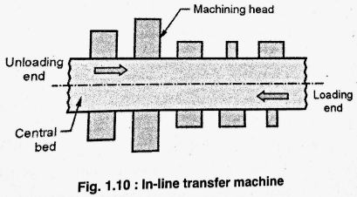

***Rotary indexing table transfer machine***

* *When the space does not allow the work to be conveyed in a straight line then it may be more convenient to transfer the work around circular line*
* *Hence, in this system the workpieces are located on a circular table and are indexed around each successive machining station which are spaced as in case of in-line transfer machine*

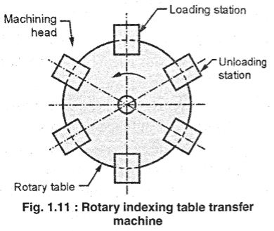

***Drum type transfer machine***

* *It is similar in concept but different in configuration to the rotary table type machine*
* *In these machines, the work fixtures are fastened to the outer periphery of a drum*
* *The arrangement enables the workpieces to transfer around a circular path to work stations placed radially at equal distances*
* *The main limitation of this method is, the machining is horizontally from sides only and the lower station always remains idle as it is practically not possible to arrange a machining head to operate in the limited space under the drum*

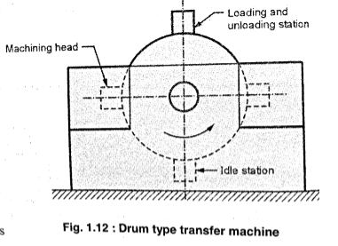

***Numerical control.***

***NC:*** *Numerical control.*

***CNC****: Computer numerical control.*

***DNC****: Dstributed numerical control.*

***NC****: Numerical control*

*They need program only once by skilled operator and then operated by own.In NC is the advance version of conventional machining.In NC ,punch tape will read the code and gives the output.*

***CNC****: Computer numerical control.*

* *CNC need program only once by skilled operator.*
* *But they use microprocessor or softwear to run the machine.*

***DNC****: Dstributed numerical control.*

*Direct Numerical Control (DNC) is a system that uses a central computer to control several machines at the same time. Configuration of DNC Machine Control Unit DNC involved the control of a number of machine tools by a single mainframe computer through direct connection and in real time. The tape reader is omitted in DNC System, thus relieving the system of its least reliable components. Instead of using the tape reader, the part program is transmitted to the machine tool directly from the computer memory. The DNC Computer is designed to provide the instructions to each machine tool on the demand. DNC also involves the data collection and processing from the machine tool back to the computer.*

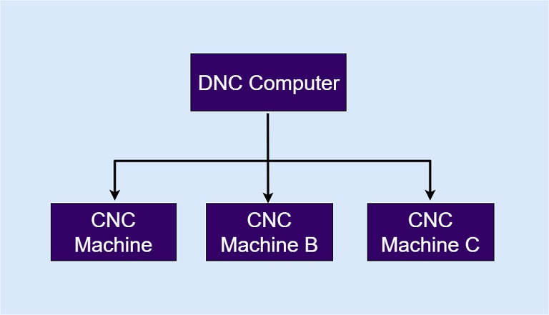

***COMPONENTS OF NC SYSTEM:***

***OR***

***ELEMENTS OF NC SYSTEM:***

*There are three important components of the numerical control or NC system. These are:  
1) Program of instructions*

*2) Controller unit, also called as the machine control unit (MCU) and*

*3) Machine tool.*

## *Parts of the Numerical Control Machine.*

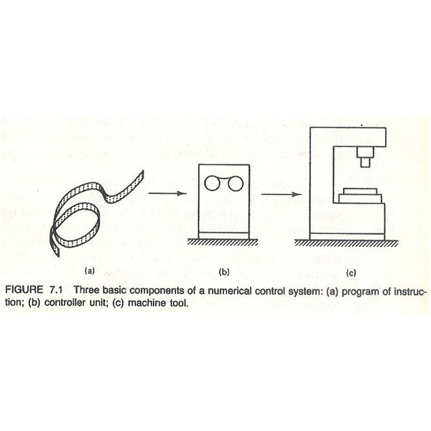

## *1) Program of Instructions*

* *The typical desktop program gives the instructions to the computers to perform certain functions. The program of instructions of the NC machine is the step-by-step set of instructions that tells the machines what it has to do. These instructions can tell the machine to turn the piece of metal to certain diameter, drill the hole of certain diameter up to certain length, form certain shape etc. The set of instructions are coded in numerical or symbolic form and written on certain medium that can be interpreted by the controller unit of the NC machine. The mediums commonly used earlier for writing the instructions were punched cards, magnetic tapes and 35mm motion picture film, but now 1 inch wide punched tape is used more commonly.*
* *The program instructions are written by the expert who has programming knowledge as well the machining knowledge. The person should know the various steps of the machining required to manufacture a particular product and should be able to write these steps in the form of the program that can be understood by the control unit of the NC machine, which would eventually direct the machine tool to perform the required machining operations.*
* *One can also input the instructions directly into the controller unit manually, this method is called as manual data input (MDI), which is used for very simple jobs. Then there is direct numerical control method (DNC) in which the machines are controlled by the computers by direct link omitting the tape reader.*

## *2) Controller Unit or Machine Controller Unit (MCU)*

* *The controller unit is most vital parts part of the NC and CNC machines. The controller unit is made of the electronics components. It reads and interprets the program of instructions and converts them in the mechanical actions of the machine tool. Thus the controller unit forms an important link between the program and the machine tool. The control unit operates the machines as per the set of instructions given to it.*
* *The typical control unit comprises of tape reader, a date buffer, signal output channels to the machine tools, feedback channel from the machine tool, and the sequence control to coordinate the overall machining operation.*
* *Initially, the set of instructions from the punched tape are read by the tape reader, which is sort of the electromechanical devise. The data from the tape is stored into the data buffer in form of logical blocks of instructions with each block resulting in certain sequence of operations.*
* *One important thing to note about the controller unit here is that all the modern NC machines are equipped with the microcomputer that acts as the controller unit. The program is fed into the computer directly and the computer controls the working the machine tool. Such machines are called as Computer Controller Machines (CNC) machines.*

## *3) Machine Tool*

* *It is the machine tool that performs the actual machining operations. The machine tool can be any machine like lathe, drilling machine, milling machine etc. The machine tool is the controlled part of the NC system. In case of the CNC machines, the microcomputer operates the machine as per the set of instructions or the program.*
* *The NC machine also have the control panel or control console that contains the dials and switches using which the operator runs the NC machine. There are also displays to display information to the user. Most of the modern NC machines are now called as the CNC machines.*

***Application of NC****:*

1. High dimensional accuracy, reduced scrap.
2. Greater flexible in operation, so a wide variety of products can be manufactured.
3. Machine utilization is as high as 85 to 90% compared to conventional machines having less than 40%, increased rate of production.
4. Complicated profiles can be easily programmed and machined.
5. Change in design of workpieces can be easily incorporated as it requires only change in the programme.
6. Better production control, the lesser requirement of jigs and fixtures.
7. Reduced floor space requirement.
8. Product development is easier and faster.
9. A less skilled operator is sufficient.

**Disadvantages of NC Machine**

1. The cost of the machine is very high.
2. Programming training is required.
3. The skilled programmer is required.
4. Higher maintenance cost.
5. Higher skilled workers are needed.

## Types of NC Systems

Following are the main three types of NC system according to the motion control system:

1. Point to Point
2. Straight cut
3. Contouring

The classification is related to the number of control over the relative motion between the workpiece and the cutting tool. Minimal control is placed on the equipment speed along with the point to point system. Contouring describes the highest level of control.

***Point to point:***

*Some machine tools for example drilling, boring and tapping machines etc, require the cutter and the work piece to be placed at a certain fixed relative positions at which they must remain while the cutter does its work. These machines are known as point-to-point machines. The control equipment for use with them is known as point-to-point control equipment. Feed rates need not to be programmed. In theses machine tools, each axis is driven separately. In a point-to-point control system, the dimensional information that must be given to the machine tool will be a series of required position of the two slides. Servo systems can be used to move the slides and no attempt is made to move the slide until the cutter has been retracted back.*

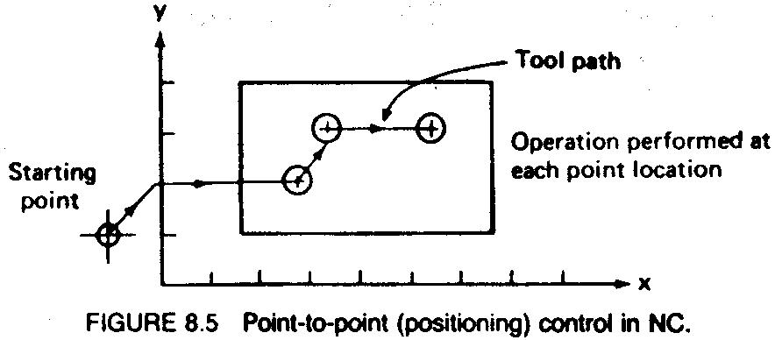

***Straight Line Motion Control System*** *:*

*The NC systems, in which the tool works along a straight line in the direction of a major coordinate axis, such as along the direction of feed during turning, boring or milling operation at a controlled rate, are known as Straight line control system.*

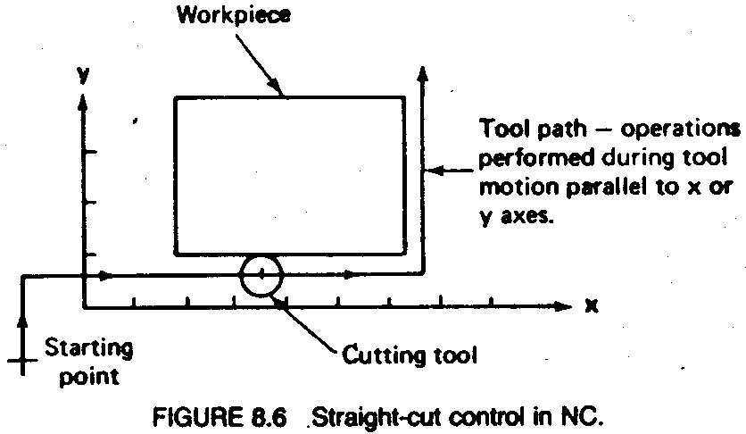

***Contouring or Continuous Path Motion Control System :***

*Other type of machine tools involves motion of work piece with respect to the cutter while cutting operation is taking place. These machine tools include milling, routing machines etc. and are known as contouring machines and the controls required for their control are known as contouring control. Contouring machines can also be used as point-to-point machines, but it will be uneconomical to use them unless the work piece also requires having a contouring operation to be performed on it. These machines require simultaneous control of axes. In contouring machines, relative positions of the work piece and the tool should be continuously controlled. The control system must be able to accept information regarding velocities and positions of the machines slides. Feed rates should be*

*Programmed.*

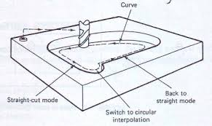

***NC COORDINATE SYSTEMS****: According to positioning and programming*

*The distances or angles which specify the position of a point, line, circle or any other geometrical figure with reference to a series of intersecting planes or planes and cylinders define coordinate systems. There are two methods of listing the coordinates of points in NC systems, which can be used independently or in combination.*

***Absolute Coordinate System*** *:*

*In an absolute system all references are made to the origin of the coordinate system. All commands of motion are defined by the absolute coordinate referred to the origin.*

***Ex:***

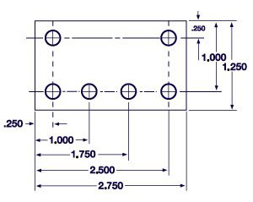

***Incremental Coordinate System*** *:*

*This type of control always uses as a reference to the preceding point in a sequence of points. The*

***Ex:***

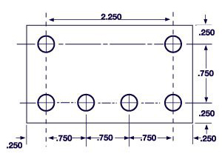

***Interpolation:***

*Interpolation, which is necessary for any type of programming, consists of generating data points between given coordinate axis positions.The interpolato****r****is either an electronic hardware device for a NC system, or a software program for a CNC system.*

***Co ordinate system in NC system:***

***Fixed zero and floating zero****: -The programmer must determine the position of the tool relative to the origin (zero point) of the coordinate system. NC machines have either of two methods for specifying the zero point. The first possibility is for the machine to have a fixed zero. In this case, the origin is always located at the same position on the machine table. Usually, that position is the southwest corner (lower lefthand corner) of the table and all tool locations will be defined by positive x and y coordinates. The second and more common feature on modern NC machines allows the machine operator to set the zero point at any position on the machine table. This feature is called floating zero. The part programmer is the one who decides where the zero point should be located. The decision is based on part programming convenience.* ***For example****, the workpart may be symmetrical and the zero point should be established at the center of symmetry. The location of the zero point is communicated to the machine operator. At the beginning of the job, the operator moves the tool under manual control to some "target point" on the table. The target point is some convenient place on the workpiece or table for the operator to position the tool. For example, it might be a predrilled hole in the workpiece. The target point has been referenced to the zero point by the part programmer. In fact, the programmer may have selected the target point as the zero point for tool positioning. When the tool has been positioned at the target point, the machine operator a “zero” button on the machine tool, which tells the machine where the origin is located for subsequent tool movement.*

***STRUCTURE OF PART PROGRAMMING:***

*The main program is first read or accessed on machine tool when the entire part program sequence is run. Normally, the controller operates according to one program. In this case the main program is also the part program. This controlling program can then call a number of smaller programs into operation. These smaller programs, called Sub Programs. These subprograms are generally used to perform repeat tasks, before returning control back to the main program.*

*Each block, or program line, contains addresses which appear in this order:*

*N, G, X, Y, Z, F, M, S, T;*

*This order should be maintained throughout every block in the program, although individual blocks may not necessarily contain all these addresses.*

*Meaning of addresses:*

*G  - Refers to the G code (Preparatory function).*

*X   - Refers to the distance travelled by the tool in the X axis direction.*

*Y  - Refers to the distance travelled by the tool in the Y axis direction.*

*Z   - Refers to the distance travelled by the tool in the Z axis direction.*

*F   - Refers to the feed rate.*

*M  - Refers to the M code (Miscellaneous function).*

*S   - Refers to the spindle speed.*

*T  - Refers to the tooling management.*

*[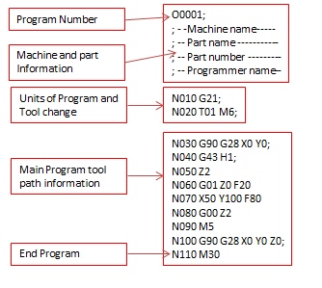](http://4.bp.blogspot.com/-4SVY_hKivq8/U5gBrWUqCoI/AAAAAAAAAH8/NN-JGBNHnGc/s1600/Main+Program+structure.png)*

***G codes and M codes:***

|  |  |  |  |  |  |
| --- | --- | --- | --- | --- | --- |
|  | [***G00***](https://www.cnccookbook.com/CCCNCGCodeG00G01.htm) | ***Motion*** | *Move in a straight line at rapids speed.* | *XYZ of endpoint* |  |
|  | [***G01***](https://www.cnccookbook.com/CCCNCGCodeG00G01.htm) | ***Motion*** | *Move in a straight line at last speed commanded by a (F)eedrate* | *XYZ of endpoint* |  |
|  | [***G02***](https://www.cnccookbook.com/CCCNCGCodeArcsG02G03.htm) | ***Motion*** | *Clockwise circular arc at (F)eedrate* | *XYZ of endpoint IJK relative to center R for radius* |  |
|  | [***G03***](https://www.cnccookbook.com/CCCNCGCodeArcsG02G03.htm) | ***Motion*** | *Counter-clockwise circular arc at (F)eedrate* | *XYZ of endpoint IJK relative to center R for radius* |  |
|  | [***G04***](https://www.cnccookbook.com/g04-gcode-pause-dwell/) | ***Motion*** | *Dwell: Stop for a specified time.* | *P for milliseconds X for seconds* |  |
|  | ***G05*** | ***Motion*** | *FADAL Non-Modal Rapids* |  |  |
|  | [***G09***](https://www.cnccookbook.com/improve-accuracy-g09-g61-exact-stop-and-g60-anti-backlash/) | ***Motion*** | *Exact stop check* |  |  |
|  |  |  |  |  |  |
|  | [***G10***](https://www.cnccookbook.com/g10-g-code-fanuc-cnc-machining-haas/) | ***Compensation*** | *Programmable parameter input* |  |  |
|  | [***G15***](https://www.cnccookbook.com/CCCNCGCodeG15G16PolarCoordinates.htm) | ***Coordinate*** | *Turn Polar Coordinates OFF, return to Cartesian Coordinates* |  |  |
|  | [***G16***](https://www.cnccookbook.com/CCCNCGCodeG15G16PolarCoordinates.htm) | ***Coordinate*** | *Turn Polar Coordinates ON* |  |  |
|  | [***G17***](https://www.cnccookbook.com/CCCNCGCodeCoordinates.htm) | ***Coordinate*** | *Select X-Y plane* |  |  |
|  | [***G18***](https://www.cnccookbook.com/CCCNCGCodeCoordinates.htm) | ***Coordinate*** | *Select X-Z plane* |  |  |
|  | [***G19***](https://www.cnccookbook.com/CCCNCGCodeCoordinates.htm) | ***Coordinate*** | *Select Y-Z plane* |  |  |
|  | [***G20***](https://www.cnccookbook.com/CCCNCGCodeG20G21MetricImperialUnitConversion.htm) | ***Coordinate*** | *Program coordinates are inches* |  |  |
|  | [***G21***](https://www.cnccookbook.com/CCCNCGCodeG20G21MetricImperialUnitConversion.htm) | ***Coordinate*** | *Program coordinates are mm* |  |  |
|  | [***G27***](https://www.cnccookbook.com/CCCNCGCodeG28ReturntoReference.htm) | ***Motion*** | *Reference point return check* |  |  |
|  | [***G28***](https://www.cnccookbook.com/CCCNCGCodeG28ReturntoReference.htm) | ***Motion*** | *Return to home position* |  |  |
|  | [***G29***](https://www.cnccookbook.com/CCCNCGCodeG28ReturntoReference.htm) | ***Motion*** | *Return from the reference position* |  |  |
|  | [***G30***](https://www.cnccookbook.com/CCCNCGCodeG28ReturntoReference.htm) | ***Motion*** | *Return to the 2nd, 3rd, and 4th reference point* |  |  |
|  | ***G32*** | ***Canned*** | *Constant lead threading (like G01 synchronized with spindle)* |  |  |
|  | ***G40*** | ***Compensation*** | *Tool cutter compensation off (radius comp.)* |  |  |
|  | ***G41*** | ***Compensation*** | *Tool cutter compensation left (radius comp.)* |  |  |
|  | ***G42*** | ***Compensation*** | *Tool cutter compensation right (radius comp.)* |  |  |
|  | ***G43*** | ***Compensation*** | *Apply tool length compensation (plus)* |  |  |
|  | ***G44*** | ***Compensation*** | *Apply tool length compensation (minus)* |  |  |
|  | ***G49*** | ***Compensation*** | *Tool length compensation cancel* |  |  |
|  | [***G50***](http://s3.cnccookbook.com/CCCNCGCodeG51Scalingt.html) | ***Compensation*** | *Reset all scale factors to 1.0* |  |  |
|  | [***G51***](http://s3.cnccookbook.com/CCCNCGCodeG51Scalingt.html) | ***Compensation*** | *Turn on scale factors* |  |  |
|  | [***G52***](https://www.cnccookbook.com/g54-g92-g52-work-offsets-cnc-g-code/) | ***Coordinate*** | *Local workshift for all coordinate systems: add XYZ offsets* |  |  |
|  | [***G53***](https://www.cnccookbook.com/g54-g92-g52-work-offsets-cnc-g-code/) | ***Coordinate*** | *Machine coordinate system (cancel work offsets)* |  |  |
|  | [***G54***](https://www.cnccookbook.com/g54-g92-g52-work-offsets-cnc-g-code/) | ***Coordinate*** | *Work coordinate system (1st Workpiece)* |  |  |
|  | [***G55***](https://www.cnccookbook.com/g54-g92-g52-work-offsets-cnc-g-code/) | ***Coordinate*** | *Work coordinate system (2nd Workpiece)* |  |  |
|  | [***G56***](https://www.cnccookbook.com/g54-g92-g52-work-offsets-cnc-g-code/) | ***Coordinate*** | *Work coordinate system (3rd Workpiece)* |  |  |
|  | [***G57***](https://www.cnccookbook.com/g54-g92-g52-work-offsets-cnc-g-code/) | ***Coordinate*** | *Work coordinate system (4th Workpiece)* |  |  |
|  | [***G58***](https://www.cnccookbook.com/g54-g92-g52-work-offsets-cnc-g-code/) | ***Coordinate*** | *Work coordinate system (5th Workpiece)* |  |  |
|  | [***G59***](https://www.cnccookbook.com/g54-g92-g52-work-offsets-cnc-g-code/) | ***Coordinate*** | *Work coordinate system (6th Workpiece)* |  |  |
|  | [***G61***](https://www.cnccookbook.com/improve-accuracy-g09-g61-exact-stop-and-g60-anti-backlash/) | ***Other*** | *Exact stop check mode* |  |  |
|  | ***G62*** | ***Other*** | *Automatic corner override* |  |  |
|  | ***G63*** | ***Other*** | *Tapping mode* |  |  |
|  | ***G64*** | ***Other*** | *Best speed path* |  |  |
|  | [***G65***](https://www.cnccookbook.com/CCCNCGCodeSubprograms.htm) | ***Other*** | *Custom macro simple call* |  |  |
|  | [***G68***](https://www.cnccookbook.com/CCCNCGCodeG68G69CoordinateRotation.htm) | ***Coordinate*** | *Coordinate System Rotation* |  |  |
|  | [***G69***](https://www.cnccookbook.com/CCCNCGCodeG68G69CoordinateRotation.htm) | ***Coordinate*** | *Cancel Coordinate System Rotation* |  |  |
|  | [***G73***](https://www.cnccookbook.com/g81-g73-g83-drill-peck-canned-cycle/) | ***Canned*** | *High speed drilling cycle (small retract)* |  |  |
|  | ***G74*** | ***Canned*** | *Left hand tapping cycle* |  |  |
|  | ***G76*** | ***Canned*** | *Fine boring cyle* |  |  |
|  | [***G80***](https://www.cnccookbook.com/g81-g73-g83-drill-peck-canned-cycle/) | ***Canned*** | *Cancel canned cycle* |  |  |
|  | [***G81***](https://www.cnccookbook.com/g81-g73-g83-drill-peck-canned-cycle/) | ***Canned*** | *Simple drilling cycle* |  |  |
|  | ***G82*** | ***Canned*** | *Drilling cycle with dwell (counterboring)* |  |  |
|  | [***G83***](https://www.cnccookbook.com/g81-g73-g83-drill-peck-canned-cycle/) | ***Canned*** | *Peck drilling cycle (full retract)* |  |  |
|  | ***G84*** | ***Canned*** | *Tapping cycle* |  |  |
|  | ***G85*** | ***Canned*** | *Boring canned cycle, no dwell, feed out* |  |  |
|  | ***G86*** | ***Canned*** | *Boring canned cycle, spindle stop, rapid out* |  |  |
|  | ***G87*** | ***Canned*** | *Back boring canned cycle* |  |  |
|  | ***G88*** | ***Canned*** | *Boring canned cycle, spindle stop, manual out* |  |  |
|  | ***G89*** | ***Canned*** | *Boring canned cycle, dwell, feed out* |  |  |
|  | [***G90***](https://www.cnccookbook.com/g91-g90-g-code-cnc-absolute-incremental-programming/) | ***Coordinate*** | *Absolute programming of XYZ (type B and C systems)* |  |  |
|  | [***G90.1***](https://www.cnccookbook.com/g91-g90-g-code-cnc-absolute-incremental-programming/) | ***Coordinate*** | *Absolute programming IJK (type B and C systems)* |  |  |
|  | [***G91***](https://www.cnccookbook.com/g91-g90-g-code-cnc-absolute-incremental-programming/) | ***Coordinate*** | *Incremental programming of XYZ (type B and C systems)* |  |  |
|  | [***G91.1***](https://www.cnccookbook.com/g91-g90-g-code-cnc-absolute-incremental-programming/) | ***Coordinate*** | *Incremental programming IJK (type B and C systems)* |  |  |
|  | [***G92***](https://www.cnccookbook.com/g54-g92-g52-work-offsets-cnc-g-code/) | ***Coordinate*** | *Offset coordinate system and save parameters* |  |  |
|  | ***G92 (alternate)*** | ***Motion*** | *Clamp of maximum spindle speed* | *S* |  |
|  | ***G92.1*** | ***Coordinate*** | *Cancel offset and zero parameters* |  |  |
|  | ***G92.2*** | ***Coordinate*** | *Cancel offset and retain parameters* |  |  |
|  | ***G92.3*** | ***Coordinate*** | *Offset coordinate system with saved parameters* |  |  |
|  | ***G94*** | ***Motion*** | *Units per minute feed mode. Units in inches or mm.* |  |  |
|  | ***G95*** | ***Motion*** | *Units per revolution feed mode. Units in inches or mm.* |  |  |
|  | [***G96***](https://www.cnccookbook.com/CCCNCGCodeG96ConstantSurfaceSpeed.htm) | ***Motion*** | *Constant surface speed* |  |  |
|  | [***G97***](https://www.cnccookbook.com/CCCNCGCodeG96ConstantSurfaceSpeed.htm) | ***Motion*** | *Cancel constant surface speed* |  |  |
|  | [***G98***](https://www.cnccookbook.com/g98-g-code-g99-g-code-canned-cycle-return-feedrate-modes/) | ***Canned*** | *Return to initial Z plane after canned cycle* |  |  |
|  | [***G99***](https://www.cnccookbook.com/g98-g-code-g99-g-code-canned-cycle-return-feedrate-modes/) | ***Canned*** | *Return to initial R plane after canned cycle* |  |  |
|  |  |  |  |  |  |
|  | | | | | |

|  |  |  |  |  |  |
| --- | --- | --- | --- | --- | --- |
| *M-Codes* | | | | | |
|  | ***M00*** | ***M-Code*** | *Program Stop (non-optional)* |  |  |
|  | ***M01*** | ***M-Code*** | *Optional Stop: Operator Selected to Enable* |  |  |
|  | ***M02*** | ***M-Code*** | *End of Program* |  |  |
|  | [***M03***](https://www.cnccookbook.com/g-code-cheat-sheet-mdi/) | ***M-Code*** | *Spindle ON (CW Rotation)* |  |  |
|  | [***M04***](https://www.cnccookbook.com/g-code-cheat-sheet-mdi/) | ***M-Code*** | *Spindle ON (CCW Rotation)* |  |  |
|  | [***M05***](https://www.cnccookbook.com/g-code-cheat-sheet-mdi/) | ***M-Code*** | *Spindle Stop* |  |  |
|  | ***M06*** | ***M-Code*** | *Tool Change* |  |  |
|  | [***M07***](https://www.cnccookbook.com/g-code-cheat-sheet-mdi/) | ***M-Code*** | *Mist Coolant ON* |  |  |
|  | [***M08***](https://www.cnccookbook.com/g-code-cheat-sheet-mdi/) | ***M-Code*** | *Flood Coolant ON* |  |  |
|  | [***M09***](https://www.cnccookbook.com/g-code-cheat-sheet-mdi/) | ***M-Code*** | *Coolant OFF* |  |  |
|  |  |  |  |  |  |
|  | ***M29*** | ***M-Code*** | *Rigid Tapping Mode on Fanuc Controls* |  |  |
|  | ***M30*** | ***M-Code*** | *End of Program, Rewind and Reset Modes* |  |  |
|  |  |  |  |  |  |
|  | [***M97***](https://www.cnccookbook.com/CCCNCGCodeSubprograms.htm) | ***M-Code*** | *Haas-Style Subprogram Call* |  |  |
|  | [***M98***](https://www.cnccookbook.com/CCCNCGCodeSubprograms.htm) | ***M-Code*** | *Subprogram Call* |  |  |
|  | [***M99***](https://www.cnccookbook.com/CCCNCGCodeSubprograms.htm) | ***M-Code*** | *Return from Subprogram* |  |  |

***Ex:***

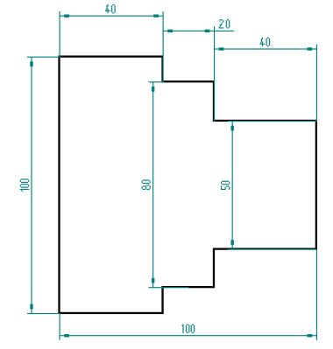

## *CNC Program*

*N05G94M06T0101*

*N10G00X0Z0M04S600*

*N15G01X50F30*

*N20G01Z-40*

*N25G01X80*

*N30G01Z-60*

*N35G01X100*

*N40G01Z-100*

*N45G00X120*

*N50G00Z10*

*N55M05*

*N60M30*

***Direct numerical control****(****DNC****)*

*also known as****distributed numerical control****is a common*[*manufacturing*](https://en.wikipedia.org/wiki/Manufacturing)*term for networking*[*CNC*](https://en.wikipedia.org/wiki/CNC)[*machine tools*](https://en.wikipedia.org/wiki/Machine_tools)*. On some CNC machine*[*controllers*](https://en.wikipedia.org/wiki/Control_theory)*, the available memory is too small to contain the machining program (for example machining complex surfaces), so in this case the program is stored in a separate computer and sent directly to the machine, one block at a time. If the computer is connected to a number of machines it can distribute programs to different machines as required. Usually, the manufacturer of the control provides suitable DNC software. However, if this provision is not possible, some software companies provide DNC applications that fulfill the purpose. DNC networking or DNC communication is always required when*[*CAM*](https://en.wikipedia.org/wiki/Computer-aided_manufacturing)*programs are to run on some CNC machine control.*

**

***Components of DNC:***

* *Central or mainframe computer.*
* *Buulk memory.*
* *Telecommunication line.*
* *M/C tool*

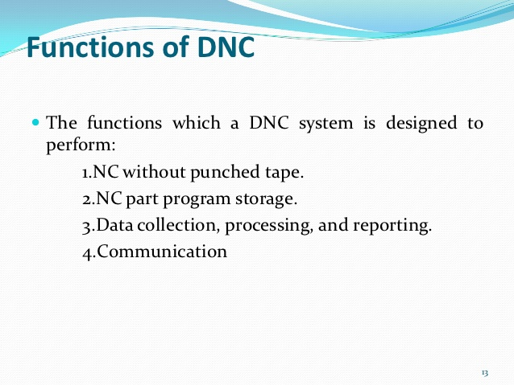

***Benefits of DNC:***

* *It saves time.*
* *It increases the productivity.*
* *It provides the greater flexibility.*

***Robot Technology***

***Robot:***

According to the history of technology the term robot is derived from Czech that means slave labour. A robotis a machine designed to execute one or more tasks automatically with speed and precision. There are as many different types of robotsas there are tasks for them to perform. Robotsthat resemble humans are known as androids; however, many robotsaren't built on the human model.

***Industrial robot:***

*It consists of a no of rigid links connected by joints and control by computer.*

***Objective:***

* **To increase the the productivity.**
* To rise the quality level of the product.
* To minimize the labour requirement.
* To reduce the production time.
* **To improve existing manufacturing process.**

***Robot anatomy:***

The manipulator of an industrial robot is constructed of a series of joints and links. Robot anatomy is concerned with the types and sizes of these joints and links and other aspects of the manipulator's physical construction.

**1 Joints and Links**

A joint of an industrial robot is similar to a joint in the human body: It provides relative motion between two parts of the body. Each joint, or axis as it is sometimes called, provides the robot with a so called degree-of-freedom (d.o.f.) of motion. In nearly all cases, only one degree of freedom is associated with a joint. Robots are often classified according to the total number of degrees-of-freedom they possess. Connected to each joint are two links, an input link and an output link. Links are the rigid components of the robot manipulator. The purpose of the joint is to provide controlled relative movement between the input link and the output link.

Most robots are mounted on a stationary base on the floor. Let us refer to that base and its connection to the first joint as link 0.1t is the input link to joint 1, the first in the series of joints used in the construction of the robot. The output link of joint 1 is link 1. Link 1 is the input link to joint 2, whose output link is link 2, and so forth. This joint-link numbering scheme is illustrated in Figure 7.1.

Nearly all industrial robots have mechanical joints that can be classified into one of five types: two types that provide translational motion and three types that provide rotary motion. These joint types are illustrated in Figure 7.2 and are based on a scheme described in [6]. The five joint types are:

Linear joint (type L-joint).The relative movement between the input link and the output link is a translational sliding motion, with the axes of the two links being parallel.

Orthogonal Joint (type U joint). This is also a translational sliding motion, but the input and output links are perpendicular to each other during the move.





Rotational Join (type R joint). This type provides rotational relative motion, with the axis of rotation perpendicular to the axes of the input and output links.

Twisting joint (type T joint) This joint also involves rotary motion, but the axis or rotation is parallel to the axes of the two links.

Revolving joint (type V joint, V from the "v' in revolving). In this joint type, the axis 0' the input link is parallel to the axis of rotation of the joint. and the axis of the output link is perpendicular to the axis of rotation.

Each of these joint types has a range over which it can be moved. The range for a translational joint is usually less than a meter. The three types of rotary joints may have a range as small as a few degrees or as large as several complete turns.

2.**Common Robot Configurations**

A robot manipulator can he divided into two sections: a body-and-arm assembly and a wrist assembly. There are usually three degrees-of-freedom associated with the body-and-arm, and either two or three degrees-of-freedom associated with the wrist. At the end of the manipulator's wrist is a device related to the task that must be accomplished by the robot. The device, called an end effector (Section 7.3), is usually either (1) a gripper for holding a work-part or (2) a tool for performing some process. The body-and-arm of the rotor is used to position the end effector. and the robot's wrist is used to orient the end effector.

Body-and-Arm Configurations. Given the five types of joints defined above, there are 5 x 5 x 5 = 125 different combinations of joints that can be used to design the body-and-arm assembly for a three-degree-of-freedom robot manipulator. In addition, there are design variations within the individual joint types [e.g.. physical size of the joint and range of motion). It is somewhat remarkable, therefore, that there are only five basic configurations commonly available in commercial industrial robots. These five configurations are:

Polar configuration. This configuration (Figure 7.3) consists of a sliding arm (L joint) actuated relative to the body, that can rotate about both a vertical axis (1' joint) and a horizontal axis (R joint).

Cylindrical configuration. This robot configuration (Figure 7.4) consists of a vertical column, relative to which an arm assembly is moved up or down. The arm can be moved in and out relative to the axis of the column. Our figure shows one possible way in which this configuration can be constructed, using a T joint to rotate the column about its axis An 1. joint is used to move the arm assembly vertically along the column, while an 0 joint is used to achieve radial movement.

Cartesian coordinate robot. Other names for this configuration include rectilinear robot and iyz robot. As shown in Figure 7 5,it is composed of three sliding joints, two of which are orthogonal.

4, Jointed-arm-robot. This robot manipulator (Figure 7.6) has the general configuration of a human arm. The jointed arm consists of a vertical column that swivels about the

base using a T joint. At the top of the column is a shoulder joint (shown as an R joint in our figure), whose output link connects to an elbow joint (another R joint)



5. SCARA. SCARA is an acronym for Selective Compliance Assembly Robot Arm. This configuration (Figure 7.7) is similar to the jointed arm robot except that the shoulder and elbow rotational axes are vertical, which means that the arm is very rigid in the vertical direction. but compliant in the horizontal direction. This permits The robot to perform insertion tasks (for assembly) in a vertical direction, where some side-to-side alignment may be needed to mate the two parts properly.

***Wrist Configurations.***

The robot's wrist is used to establish the orientation of the end effector. Robot wrists usually consist of two or three degrees-of-freedom. Figure 7.8 illustrates one possible configuration for a three-degree-of-freedom wrist assembly. The three joints are defined as: (1) roll, using a T joint to accomplish rotation about the robot's arm axis: (2) pitch, which involves up-and-down rotation, typically using a R joint; and (3) yaw, which involves right-and-left rotation, also accomplished by means of an R-joint, A two-d.o.f wrist typically includes only roll and pitch joints (T and R joints).

To avoid confusion in the pitch and yaw definitions, the wrist roll should be assumed in its center position, as shown in our figure. To demonstrate the possible confusion, consider a two-jointed wrist assembly. With the roll joint in its center position, the second joint (R joint) provides up-and-down rotation (pitch). However, if the roll position were 90 degrees from center (either clockwise or counterclockwise), the second joint would provide a right-left rotation (yaw).

The SCARA robot configuration (Figure 7.7) is unique in that it typically does not have a separate wrist assembly. As indicated in our description, it is used for insertion type assembly operations in that the insertion is made from above. Accordingly. the orientation requirements are minimal, and the wrist is therefore not needed. Orientation of the object to be inserted is sometimes required, and an additional rotary joint can be provided for this purpose. The other four body-and-arm configurations possess wrist assemblies that almost always consist of combinations of rotary joints of types Rand T.

Work Volume. The work volume (the term work envelope is also used) of the manipulator is defined as the envelope or space within which the robot can manipulate the end of its wrist. Work volume is determined by the number and types of joints in the manipulator (body-and-arm and wrist), the ranges of the various joints, and the physical sizes of the links. The shape of the work volume depends largely on the robot's configuration. A polar configuration robot tends to have a partial sphere as its work volume, a cylindrical robot has a cylindrical work envelope. and a Cartesian coordinate robot has a rectangular work volume.

3 Joint Drive Systems

Robot joints are actuated using any of three possible types of drive systems: (1) electric, (2) hydraulic, or (3) pneumatic. Electric drive systems use electric motors as joint actuators (e.g., servomotors or stepping motors, the same types of motors used in NC positioning systems, Chapter 6), Hydraulic and pneumatic drive systems use devices such as linear pistons and rotary vane actuators to accomplish the motion of the joint.

Pneumatic drive is typically limited to smaller robots used in simple material transfer applications. Electric drive and hydraulic drive are used on more-sophisticated industrial robots. Electric drive has become the preferred drive system in commercially available robots, as electric motor technology has advanced in recent years. It is more readily adaptable to computer control, which

is the dominant technology used today for robot controllers. Electric drive robots are relatively accurate compared with hydraulically powered robots. By contrast, the advantages of hydraulic drive include greater speed and strength.

Gripper:

Gripper are the most common type of end effector. They can use different gripping methods and actuation styles.

They are classified into:



**Mechanical Gripper**:

A mechanical gripper is used as an end effector in a robot for grasping the objects with its mechanically operated fingers. Mechanical Gripper. A mechanical gripper is used as an end effector in a robot for grasping the objects with its mechanically operated fingers.

**vaccum gripper:**

A robot component that uses a suction cup connected to a vacuum source to lift and handle objects.

**Magnetise Gripper:**

The Magnetic Gripper is ideal for use where end effectors and vacuum cups are typically used for lifting and moving ferromagnetic pieces such as steel sheets, blanks, and stamped parts. It is available in a 25mm bore size with four magnet strengths.

**Adhesive Gripper:**

An adhesion gripper is a robot end effector that grasps objects by literally sticking to them. In its most primitive form, this type of gripper consists of a rod, sphere, or other solid object covered with two-sided tape.

**Simple Gripper:**

Hook is the example of simple gripper.

**Sensor:**

A sensor is a window for a robot to the environment. Sensors allow robots to understand and measure the geometric and physical properties of objects in their surrounding environment, such as position, orientation, velocity, acceleration, distance, size, force, moment, temperature, weight, etc.

**1. Light Sensor:**

A light sensor detects light and creates a difference in voltage. A robot’s vision system has a computer-controlled camera that allows the robot to see and adjust its movements accordingly. The two primary light sensors in robots are Photoresistor and Photovoltaic cells. Other light sensors like phototubes, phototransistors, etc.

**2. Sound Sensor:**

Sound sensors are generally a microphone used to detect the equivalent voltage of sound and return. The sound it receives can be navigated by a simple robot. Imagine a robot turning right to a pulpit, turning left for two palpitations. Complex robots may use the same microphone for voice recognition. Sound sensors are not as easy as light sensors because sound sensors generate a minimal voltage difference which should be amplified to produce a measurable change in voltage. Voice systems also use robots with voice commands. This is useful if the trainer has to handle other objects when training robots.

**3. Proximity Sensor:**

The nearby object can be detected by a proximity sensor without physical contact. The transmitter transmits electromagnetic radiation in the adjacent sensor and receives and analyzes the interruption feedback signal. Thus, the amount of light received in the area can be used to detect the presence of nearby objects. The sensors provide a collision avoidance method for the robot.

**4. Tactile Sensors:**

Tactile Sensor is a device specifying an object’s contact. Often used in everyday objects such as elevator buttons and lamps, which dim or brighten by touching

the base, a tactile sensor allows the robot to touch and feel. These sensors are used to measure applications and gently interact with the environment. It can be sorted into two principal types: Touch Sensor and Force Sensor.

**5. Temperature Sensor:**

Temperature sensors are used to detect the surrounding temperature change. It is based on the principle of voltage difference change for a temperature change; this voltage change will provide the surrounding temperature equivalent. Temperature sensing applications include air temperature, surface temperature, immersion temperature.

**Flexible manufacturing system**

***Flexible manufacturing system (FMS):***

*A flexible manufacturing system (FMS) is a manufacturing system in which there is some amount of flexibility to react in the case of changes, whether predicted or unpredicted. This flexibility can be divided into two categories:*

1. *Machine flexibility, covers the system's ability to be changed to produce new product types, and ability to change the order of operations executed on a part.*

*2. Routing flexibility, this consists of the ability to use multiple machines to perform the same operation on a part, as well as the system’s ability to absorb large-scale changes, such as in volume, capacity, or capability.*

*Most FMS systems consist of three main systems.*

*1. The work machines which are often using computerized machines.*

*2. Material handling system to optimize parts flow.*

*3. The central control computer which controls material movements and machine flow.*

*An Industrial Flexible Manufacturing System (FMS) consists of robots, Computer-controlled Machines, Numerical controlled machines (CNC), instrumentation devices, computers, sensors, and other stand-alone systems such as inspection machines.*

* *There are different types of flexibility*
* *Basic flexibility.*
* *System flexibility.*
* *Aggregate flexibility.*

***Description of Lecture with Figure (If Any):****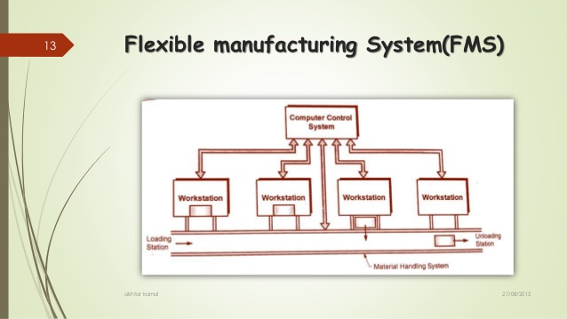*

***Basic flexibility:***

*Classified into 3 types.*

* *Machine flexibility.*
* *Material handling flexibility.*
* *Operational flexibility.*

***Machine flexibility****:Machine flexibility refers to the system's ability to produce new types of products, and its ability to change the order in which operations are executed.*

***Material handling flexibility:****Material handling is defined as any process that involves moving products or components. This could be short distances, long distances, within a building or between buildings.*

***Operational flexibility:*** *operational flexibility is defined as an index which integrates both the mix and volume flexibility. Operative data and the associated costs are used to determine the optimal level of operational flexibility in the flow shop manufacturing system.*

***System Flexibility:****It is classified as.*

* *Volume flexibility.*
* *Expansion Flexibility.*
* *Routing Flexibility.*
* *Process Flexibility.*
* *Product Flexibility.*

***Volume flexibility:****Volume flexibility is defined as the ability of an organization to change volume levels in response to changing socio-economic conditions profitably and with minimal disruptions.*

***Expansion Flexibility:***Expansion flexibility*allows for changing the production capacity in response to deviations in demand, while disregarding the assumption that management*

***Routing Flexibility:****Routing flexibility which is the ability of more than one machine to perform the same process or adjust for changes in capacity.*

***Process Flexibility:*** *Process flexibility is a concept used in process management which refers to how an operation responds to outside factors, normally changes to supply or demand. Utilizing process flexibility well should reduce the cost of external factors which impact on a process.*

***Product Flexibility:****Product flexibility can be defined as the amount of responsiveness (or adaptability) for any future change in a product design, including new products and derivatives of existing products.*

***NOTES:***

* ***Machine flexibility****- The different operation types that a machine can perform.*
* ***Material handling flexibility****- The ability to move the products within a manufacturing facility.*
* ***Operation flexibility****- The ability to produce a product in different ways.*
* ***Process flexibility****- The set of products that the system can produce.*
* ***Product flexibility****- The ability to add new products in the system.*
* ***Routing flexibility****- The different routes (through machines and workshops) that can be used to produce a product in the system.*
* ***Volume flexibility****- The ease to profitably increase or decrease the output of an existing system. At firm level, it is the ability of a firm to operate profitably at different output levels. Firms often use volume flexibility as a benchmark to assess their performance vis-à-vis their competitors.*[*[1]*](https://en.wikipedia.org/wiki/Flexibility_(engineering)#cite_note-1)
* ***Expansion flexibility****- The ability to build out the capacity of a system.*
* ***Program flexibility****- The ability to run a system automatically.*
* ***Production flexibility****- The number of products a system currently can produce.*
* ***Market flexibility****- The ability of the system to adapt to market demands.*

*These definitions yield under current conditions of the system and that no major setups are conducted or investments are made (except expansion flexibility). Many of the flexibility types are linked to each other; increasing one flexibility type also increases another. But in some cases tradeoffs between two flexibility types are needed.*

***Aggregate Flexibility :****It is classified into 3 types*

* *Production flexibility.*
* *Market flexibility.*
* *Program flexibility.*

***Production flexibility:****Flexibility in manufacturing means the ability to deal with slightly or greatly mixed parts, to allow variation in parts assembly and variations in process sequence, change the production volume and change the design of certain product being manufactured.*

***Market flexibility :*** *The ability of the system to efficiently adopt to change market condition.*

***Program flexibility :*** *It is the ability of a system to run a program for a long period without any disturbances.*

***Advantages and Disadvantages of FMS:***

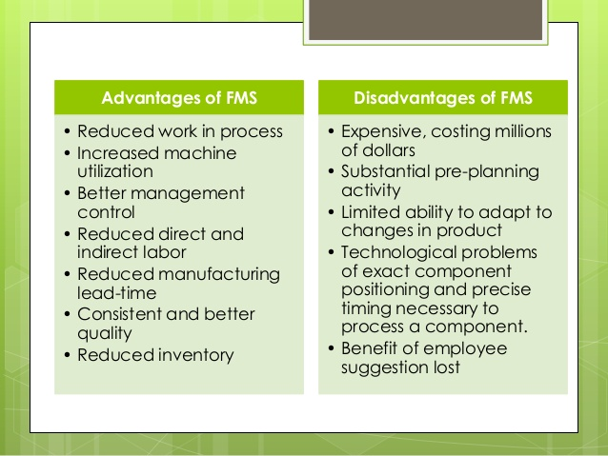

***Application of FMS:***

*Flexible manufacturing systems are typically used for mid-volume, mid-variety production. If the part or product is made in high quantities with no style variations, then a transfer line or similar dedicated production systems is most appropriate. If the parts are low volume with high variety, then numerical control, or even manual methods would be more appropriate. These application characteristics are summarized in Figure below.*

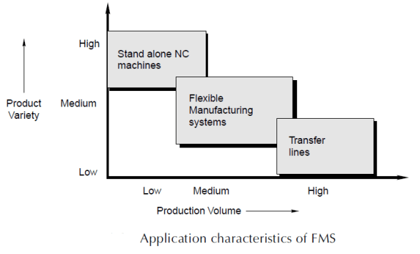

*Flexible machining systems comprise the most common application of FMS technology. Owing to the inherent flexibilities and capabilities of computer numerical control, it is possible to connect several CNC machine tools to a small central computer, and to devise automated methods for transferring workparts between the machines. Figure below shows a flexible machining system consisting of five CNC machining centers and an in-line transfer system to pick up parts from a central load/unload station and move them to the appropriate machine.*

*In addition to machining systems, other types of flexible manufacturing systems have also been developed, although the*

***Hardware components of FMS****:*

*FMS hardware includes workstations, material handling system, and central control computer. The workstations are CNC machines in a machining type system, plus inspection stations, parts cleaning and other systems as needed. A central chip conveyor system is often installed below floor level.*

*The material handling system is the means by which parts are moved between stations. The material handling system usually includes a limited capability to store parts. Handling systems suitable for automated manufacturing include roller conveyors, in-floor towline carts, automated guided vehicles, and industrial robots. The most appropriate type depends on part size and geometry, as well as factors relating to economics and compatibility with other FMS components. Non-rotational parts are often moved in a FMS on pallet fixtures, so the pallets are designed for the particular handling system, and the fixtures are designed to accommodate the various part geometries in the family. Rotational parts are often handled by robots, if weight is not a limiting factor.*

*The handling system establishes the basic layout of the FMS. Five layout types can be distinguished:*

* *in-line*
* *loop*
* *ladder*
* *open field*
* *robot centerd cell*

*All these basic layouts are shown below in same order.*

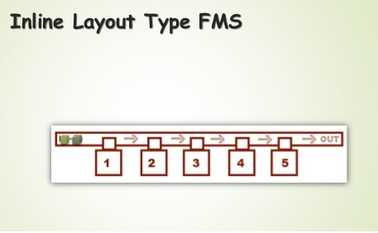

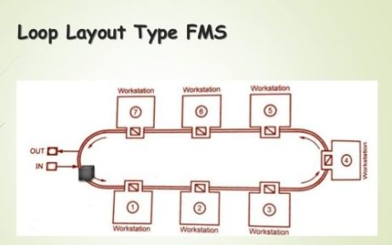

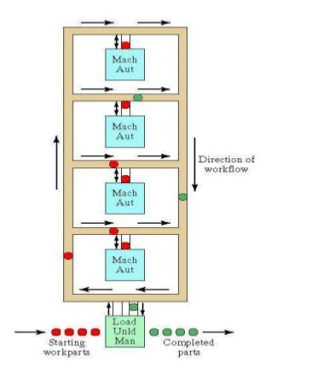

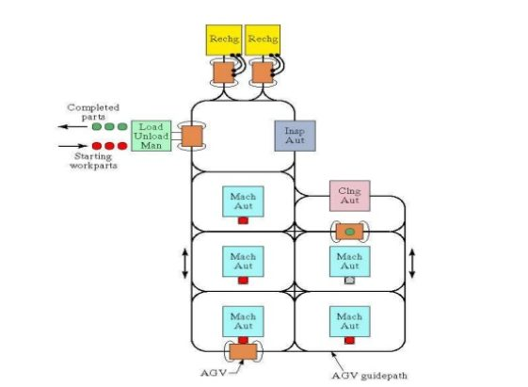

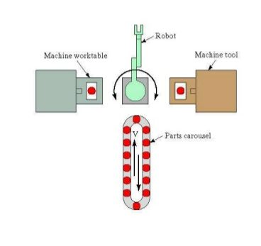

* *The****in-line layout****uses a linear transfer system to move parts between processing stations and load/unload station(s). The in-line transfer system is usually capable of two-directional movement; if not, then the FMS operates much like a transfer line, and the different part styles made on the system must follow the same basic processing sequence due to the one-direction flow.*
* *The****loop Layout****consists of a conveyor loop with workstations located around its periphery. This configuration permits any processing sequence, because any station is accessible from any other station. This is also true for the****ladder layout****, in which workstations are located on the rungs of the ladder.*
* *The****open field layout****is the most complex FMS configuration, and consists of several loops tied together.*
* *Finally,****the robot-centered cell****consists of a robot whose work volume includes the load/unload positions of the machines in the cell.*
* *The FMS also includes a central computer that is interfaced to the other hardware components. In addition to the central computer, the individual machines and other components generally have microcomputers as their individual control units. The function of the central computer is to coordinate the activities of the components so as to achieve a smooth overall operation of the system. It accomplishes this function by means of software.*

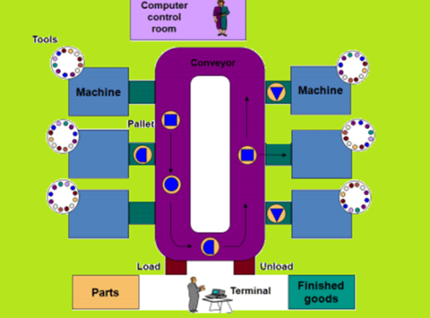

###### 2.**FMS software**

*FMS software consists of modules associated with the various functions performed by the manufacturing system. For example, one function involves downloading NC part programs to the individual machine tools: another function is concerned with controlling the material handling system; another is concerned with tool management.*

***3.Human labour:***

*An additional component in the operation of a flexible manufacturing system is human labor. Duties performed by human workers include;*

* *loading and unloading parts from the system*
* *changing and setting cutting tools*
* *maintenance and repair of equipment*
* *NC part programming*
* *programming and operating the computer system*
* *overall management of the system*

##### ***Applications of Flexible Manufacturing Systems***

*Flexible manufacturing systems are typically used for mid-volume, mid-variety production. If the part or product is made in high quantities with no style variations, then a transfer line or similar dedicated*[*production system*](https://www.mechlectures.com/economic-product-design-considerations-machining/)*is most appropriate. If the parts are low volume with high variety, then numerical control, or even manual methods would be more appropriate. These application characteristics are summarized in Figure below.*

*Flexible machining systems comprise the most common application of FMS technology. Owing to the inherent flexibilities and capabilities of computer numerical control, it is possible to connect several CNC machine tools to a small central computer, and to devise automated methods for transferring workparts between the machines. Figure below shows a flexible machining system consisting of five CNC machining centers and an in-line transfer system to pick up parts from a central load/unload station and move them to the appropriate machining.*

*In addition to machining systems, other types of flexible manufacturing systems have also been developed.*

***3.Human labour:***

*An additional component in the operation of a flexible manufacturing system is human labor. Duties performed by human workers include;*

* *loading and unloading parts from the system*
* *changing and setting cutting tools*
* *maintenance and repair of equipment*
* *NC part programming*
* *programming and operating the computer system*
* *overall management of the system*

##### ***Applications of Flexible Manufacturing Systems***

*Flexible manufacturing systems are typically used for mid-volume, mid-variety production. If the part or product is made in high quantities with no style variations, then a transfer line or similar dedicated*[*production system*](https://www.mechlectures.com/economic-product-design-considerations-machining/)*is most appropriate. If the parts are low volume with high variety, then numerical control, or even manual methods would be more appropriate. These application characteristics are summarized in Figure below.*

**

*Flexible machining systems comprise the most common application of FMS technology. Owing to the inherent flexibilities and capabilities of computer numerical control, it is possible to connect several CNC machine tools to a small central computer, and to devise automated methods for transferring workparts between the machines. Figure below shows a flexible machining system consisting of five CNC machining centers and an in-line transfer system to pick up parts from a central load/unload station and move them to the appropriate machining.*

*In addition to machining systems, other types of flexible manufacturing systems have also been developed.*

**CAD,CAM&CIM**

*CAD: computer Aided Design.*

*CAD is concerned with design engineering by using computer to support manufacturing.Product design is a critical function in the production system.*

***Reasons for Implementing a CAD System :***

*1. To increase in the productivity of the designer The CAD improves the productivity of the designer to visualize the product and its components, parts and reduces time required in synthesizing, analyzing and documenting the design.*

*2. To improve the quality of design o CAD system permits a more detailed engineering analysis and a large no. of design alternatives can be investigated. o The design errors are also reduced because of the greater accuracy provided by system.*

*3. To improve communication in design . The use of a CAD system provides better engineering drawings, more standardization in drawing, better documentation of design, few drawing errors.*

*4. To create a data base for manufacturing In the process of creating the documentation for the product design, much of the required data base to manufacture the product can be created.*

*5. Improves the efficiency of design It improves the efficiency of design process and the wastages at the design stage can be reduced.*

*There are six steps involved in the conventional* ***design process*** *as discussed below:*

***Recognition of need***

*• The first step in the designing process is to recognize necessity of that particular design.*

*• The condition under which the part is going to operate and the operation of part in that particular environment.*

*• The real problem is identified by knowing the history and difficulties faced in system. 2. Definition of problem*

*• The design involves type of shape of part, its space requirement, the material restrictions and the condition under which the part has to operate.*

*• The basic purpose of design process has to be known before starting the design.*

*• A problem may be design of a simple part or complex part.*

***Synthesis of design***

*• In this, it may be necessary to prepare a rough drawing of design part.*

*• The type of loading conditions imposed on the parts.*

*• The type of shapes which the part section can require and approximate dimension at which the different forces are located has to be provided on the sketch of part.*

*• The stresses to which the part is likely to be subjected must be analyzed and relevant formulas should be prepared.*

*• A mathematical model of design may be prepared to synthesize the parts of design.*

***Analysis and optimization***

*• The design can be analyzed for the type of loading condition as well as the geometric shape of the part.*

*• In the first stage it will be necessary to check the design of the part for safe stresses.*

*• If it is not satisfactory, then the dimensions of the part can be recalculated.*

*• The part can further be optimized for acquiring minimum dimensions, weight, volume, efficiency of the material and cost.*

*• The optimization depends on the definition of the problem and importance of a parameter.*

*• It may be sometimes necessary to optimize the part for certain operating parameters like efficiency, torque, etc.*

***Evaluation***

*• It is concerned with measuring the design against the specifications established in the problem definition phase.*

*• The evaluation often requires the fabrication and testing of model to assess operating performance, quality and reliability.*

*6. Presentation*

*• The design of component must be presented along with necessary drawings in an attractive format.*

***Geometric modelling***

*• Geometric modelling is concerned with the computer compatible mathematical description of the geometry of an object.*

*• The mathematical description allows the image of the object to be displayed and manipulated on a graphics terminal through signals from the CPU of CAD system.*

*• The software that provides geometric modelling capabilities must be designed for efficient use both by the computer and human designer.*

*• The basic form uses wire frames to represent the object.*

*• The most advanced method of geometric modelling is solid modelling in three dimensions. 2. Engineering Analysis*

*• The analysis may involve stress-strain calculations, heat transfer computation etc.*

***Reasons for Implementing a CAD System***

*1. To increase in the productivity of the designer The CAD improves the productivity of the designer to visualize the product and its components, parts and reduces time required in synthesizing, analyzing and documenting the design.*

*2. To improve the quality of design o CAD system permits a more detailed engineering analysis and a large no. of design alternatives can be investigated. o The design errors are also reduced because of the greater accuracy provided by system.*

*3. To improve communication in design The use of a CAD system provides better engineering drawings, more standardization in drawing, better documentation of design, few drawing errors.*

*4. To create a data base for manufacturing In the process of creating the documentation for the product design, much of the required data base to manufacture the product can be created.*

*5. Improves the efficiency of design It improves the efficiency of design process and the wastages at the design stage can be reduced. Conventional Design process There are six steps involved in the conventional design process as discussed below:*

***Definition of problem***

*• The design involves type of shape of part, its space requirement, the material restrictions and the condition under which the part has to operate.*

*• The basic purpose of design process has to be known before starting the design.*

*• A problem may be design of a simple part or complex part.*

*• It may be problem on optimizing certain parameters.*

***Synthesis of design***

*• In this, it may be necessary to prepare a rough drawing of design part.*

*• The type of loading conditions imposed on the parts.*

*• The type of shapes which the part section can require and approximate dimension at which the different forces are located has to be provided on the sketch of part.*

*• The stresses to which the part is likely to be subjected must be analyzed and relevant formulas should be prepared.*

*• A mathematical model of design may be prepared to synthesize the parts of design.*

**Description of Lecture with Figure (If Any):**

***Analysis and optimization***

*• The design can be analyzed for the type of loading condition as well as the geometric shape of the part.*

*• In the first stage it will be necessary to check the design of the part for safe stresses.*

*• If it is not satisfactory, then the dimensions of the part can be recalculated.*

*• The part can further be optimized for acquiring minimum dimensions, weight, volume, efficiency of the material and cost.*

*• The optimization depends on the definition of the problem and importance of a parameter.*

*• It may be sometimes necessary to optimize the part for certain operating parameters like efficiency, torque, etc.*

***Evaluation***

*• It is concerned with measuring the design against the specifications established in the problem definition phase.*

*• The evaluation often requires the fabrication and testing of model to assess operating performance, quality and reliability.*

***Presentation***

*• The design of component must be presented along with necessary drawings in an attractive format.*

***Engineering Analysis***

*• The analysis may involve stress-strain calculations, heat transfer computation etc.*

*• The analysis of mass properties is the analysis feature of CAD system that has probably the widest application.*

*• It provides properties of solid object being analyzed, such as surface area, weight, volume, center of gravity and moment of inertia.*

*• The most powerful analysis feature of CAD system is the finite element method*

***Benefits of CAD***

*• Improved engineering productivity*

*• Reduced manpower required*

*• More efficient operation*

*• Customer modification are easier to make*

*• Low wastages*

*• Improve CAD tools, as defined above, resemble guidance to the user of CAD technology. The definition should not and is not intended to, represent a restriction on utilizing it*

***Engineering design and applications****.*

*The principal purposes of this definition are the following:*

*1. To extend the utilization of current CAD/CAM systems beyond just drafting and visualization.*

*2. To customize current CAD/CAM systems to meet special design and analysis needs.*

*3. To influence the development of the next generation of CAD/CAM systems to better serve the design and manufacturing processes.*

**Tools Used for the Lecture:** CHALK, DUSTER & BLACK BOARD.

**Description of Lecture with Figure (If Any):**

***Reasons for Implementing a CAD System***

1. To increase in the productivity of the designer The CAD improves the productivity of the designer to visualize the product and its components, parts and reduces time required in synthesizing, analyzing and documenting the design.

2. To improve the quality of design o CAD system permits a more detailed engineering analysis and a large no. of design alternatives can be investigated. o The design errors are also reduced because of the greater accuracy provided by system.

3. To improve communication in design The use of a CAD system provides better engineering drawings, more standardization in drawing, better documentation of design, few drawing errors.

4. To create a data base for manufacturing In the process of creating the documentation for the product design, much of the required data base to manufacture the product can be created.

5.Improves the efficiency of design It improves the efficiency of design process and the wastages at the design stage can be reduced.

**Synthesis of design**

• In this, it may be necessary to prepare a rough drawing of design part.

• The type of loading conditions imposed on the parts.

• The type of shapes which the part section can require and approximate dimension at which *the different forces are located has to be provided on the sketch of part.*

*• The stresses to which the part is likely to be subjected must be analyzed and relevant* formulas should be prepared.

• A mathematical model of design may be prepared to synthesize the parts of design.

Analysis and optimization

**Geometric modelling**

• Geometric modelling is concerned with the computer compatible mathematical description of the geometry of an object.

• The mathematical description allows the image of the object to be displayed and manipulated on a graphics terminal through signals from the CPU of CAD system.

• The software that provides geometric modelling capabilities must be designed for efficient use both by the computer and human designer.

• The basic form uses wire frames to represent the object.

• The most advanced method of geometric modelling is solid modelling in three dimensions*.*

***CAM:***

*Computer Aided Maoperationnufacturing.CAD can be defined as the use of computer system to plan, manage and control the operation.*

## The benefits of CAM

## Using CAM has a number of benefits when it comes to creating components used in building construction.

## Compared to manually operated machines, CAM generally offers:

* Greater speed in producing components
* Greater accuracy and consistency, with each component or finished product exactly the same
* Greater efficiency as computer controlled machines do not need to take breaks
* High sophistication in terms of following complex patterns like tracks on circuit boards.

**CIM:** computer Integrated Manufacturing.

Computer-integrated manufacturing (CIM) refers to the use of computer- controlled machineries and automation systems in manufacturing products. CIM combines various technologies like computer-aided design (CAD) and computer-aided manufacturing (CAM) to provide an error-free manufacturing process that reduces manual labor and automates repetitive tasks. The CIM approach increases the speed of the manufacturing process and uses real-time sensors and closed-loop control processes to automate the manufacturing process.

**Advantages:**

1. Shorter design cycle.
2. Better quality.
3. Reduce waste.
4. Reduce manufacturing lead time.
5. Better management control.

Elements of CIM:

***There are nine major elements of a CIM system are:***

* Marketing.
* Product Design.
* Planning.
* Purchase.
* Manufacturing Engineering.
* Factory Automation Hardware.
* Warehousing.
* Finance.
* Information Management.

## Marketing:

The need for a product is identified by the marketing division. This specifications of the product, the projection of manufacturing quantities and the strategy for marketing the product are also decided by the marketing department Marketing also works out the manufacturing costs to assess the economic viability of the product.

## Product Design:

The design department of the company establishes the initial database for production of a proposed product. In a CIM system this is accomplished through activities such as geometric modelling and computer aided design while considering the product requirements and concepts generated by the creativity of the design engineer. Configuration management is an important activity in many designs. Complex designs are usually carried out by several teams working simultaneously, located often in different parts of the world. The design process is constrained by the costs that will be incurred in actual production and by the capabilities of the available production equipment and processes. The design process creates the database required to manufacture the part.

## *Planning:*

The planning department takes the database established by the design department and enriches it with production data and information to produce a plan for the production of the product. Planning involves several subsystems dealing with materials, facility, process, tools, manpower, capacity, scheduling, outsourcing, assembly, inspection, logistics etc. In a CIM system, this planning process should be constrained by the production costs and by the production equipment und process capability, in order to generate an optimized plan.

## Purchase:

The purchase departments is responsible for placing the purchase order sand follow up, ensure quality in the production process of the vendor, receive the items, arrange for inspection and supply the items to the stores or arrange timely delivery depending on the production schedule for eventual supply to manufacture and assembly.

## Manufacturing Engineering:

Manufacturing Engineering is the activity of carrying out the production of the product, involving further enrichment of the database with performance data and information about the production equipment and processes. In CIM, this requires activities like CNC programming, simulation and computer aided scheduling of the *production activity.*

## *Factory Automation Hardware:*

Factory automation equipment further enriches the database with equipment and process data, resident either in the operator or the equipment to carry out the production process. In CIM system this consists of computer controlled process machinery such as CNC machine tools, flexible manufacturing systems (FMS), Computer controlled robots, material handling systems, computer controlled assembly systems, flexibly automated inspection systems and so on.

## Warehousing:

Warehousing is the function involving storage and retrieval of raw materials, components, finished goods as well as shipment of items. In today’s complex outsourcing scenario and the need for just-in-time supply of components and subsystems, logistics and supply chain management assume great importance.

## Finance:

Finance deals with the resources pertaining to money. Planning of investment, working capital, and cash flow control, realization of receipts, accounting and allocation of funds are the major tasks of the finance departments.

## Information Management:

Information Management is perhaps one of the crucial tasks in CIM. This involves master production scheduling, database management, communication, manufacturing systems integration and management information systems. It can be seen that CIM technology ties together all the manufacturing and related functions in a company. Implementation of CIM technology thus involves basically integration of all the activities of the enterprise.

**REFERENCES**

* BOOK – GROVER
* GOOGLE